**Size 5 ¾”**

Double disc, patent Apple 2x17 pins

**Size 5 ¼”**

1. DSSI
2. SDI
3. MFM -> ST412
4. SASI
5. ESDI
6. SCSI-I 50
7. IDE
8. MFM (connector\Interface not edge.) -> ST506
9. Lisa patent Apple 2x17 pins

SMD I don't have

ESMD (SMD-E) I don't have

**Size 3 ½”**

ESDI 72 pins

ESDI 44 pins

ESDI like MFM

MFM -> ST506

IDE\ATA

MFM -> ST412 RLL

JVC unknow

Conner for Apple Hard Disk 40SC 2x17 pins

DSSI

SCSI-I 50

SCSI 68

SCA 80

FC

SSA

SATA gruby

SATA średni fotki wymiary

SATA thin fotki wymiary

SAS

**Size ISA 3 ½”**

HardCard ISA slot 3 ½”

**Size 2 ½”**

ESDI

ESDI caddy

SCSI Apple (IBM) 48 pins

IDE

IDE thick

**Size 5 ¾” (no ¼”)**

**5 ¾”** Patent Apple 2x17pins ? New World Computer Company INC. Model : Mikro Disc.

This disc consists of two almost identical discs attached to each other at the back.

Connection similar to the proprietary SCSI patent for Apple PowerBook and Lisa.

It has 2 x 17 pins socket. And power socket 6 pins. The situation is identical to the dedicated and proprietary connector in Connor CP-3045 for Apple and Lisa.

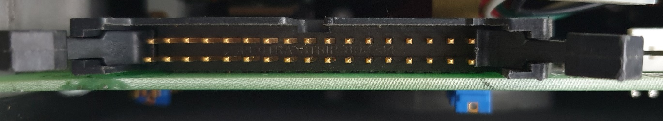

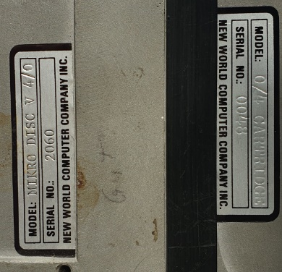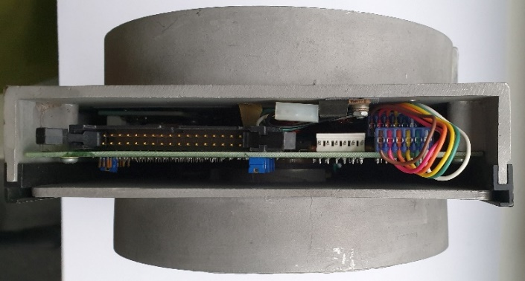

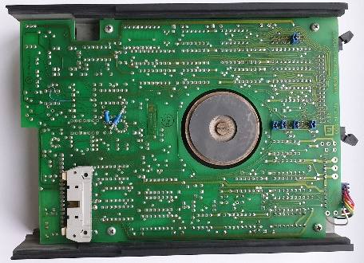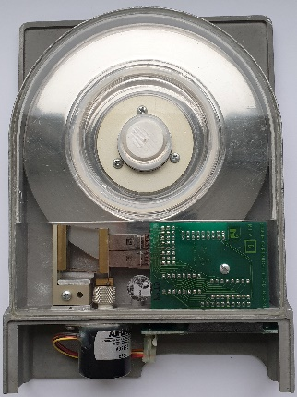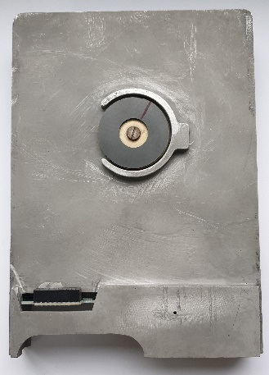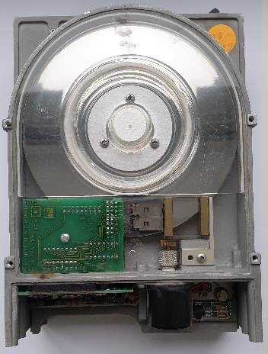

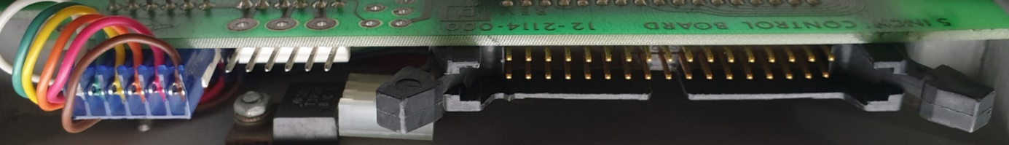

**Size 5 ¼”**

**DSSI**

DEC Model RF30 5 ¼” DSSI hard drive. 50 pin connector for data. 5 pin power connector. Data Σ=> 50 pins. DSSI **D**igital **S**torage **S**ystems **I**nterconnect. The predecessor of Parallel SCSI, i.e. SCSI-I. A bus for connecting mass storage devices and clustering VAX systems.

<https://gunkies.org/wiki/RF30>



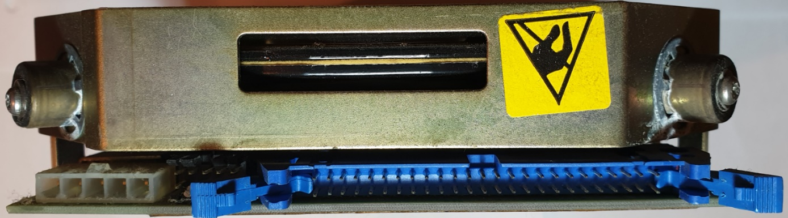

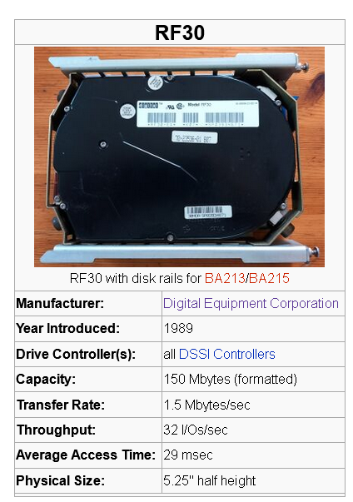

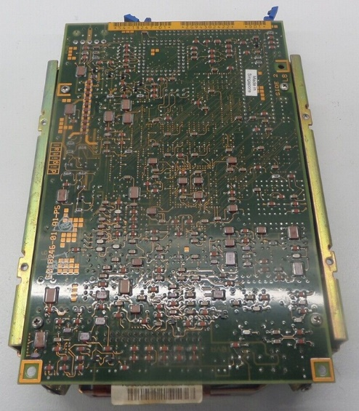

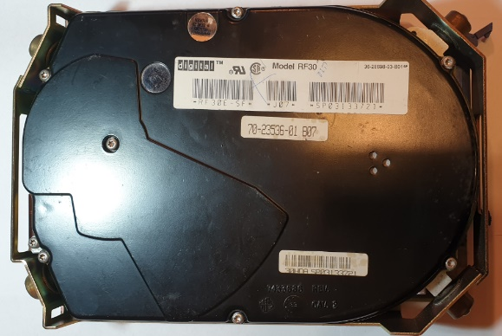

**SDI**

SDI DEC Model RA70 5 ¼” hard drive. SDI **S**tandard **D**isk **I**nterconnect. Connector 2x10 + 2x4 +2x4 = 36 pin. Power connector 4 pins.

<https://gunkies.org/wiki/RA70_disk_drive>

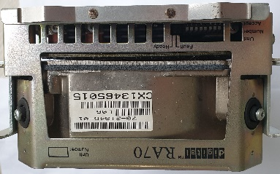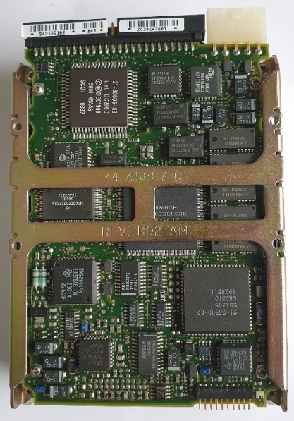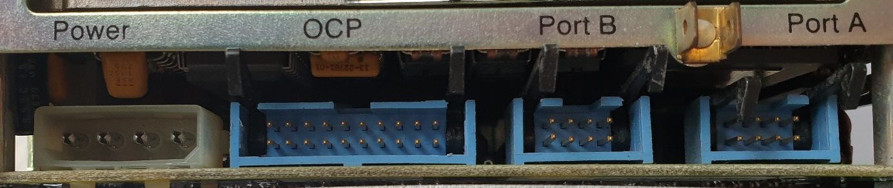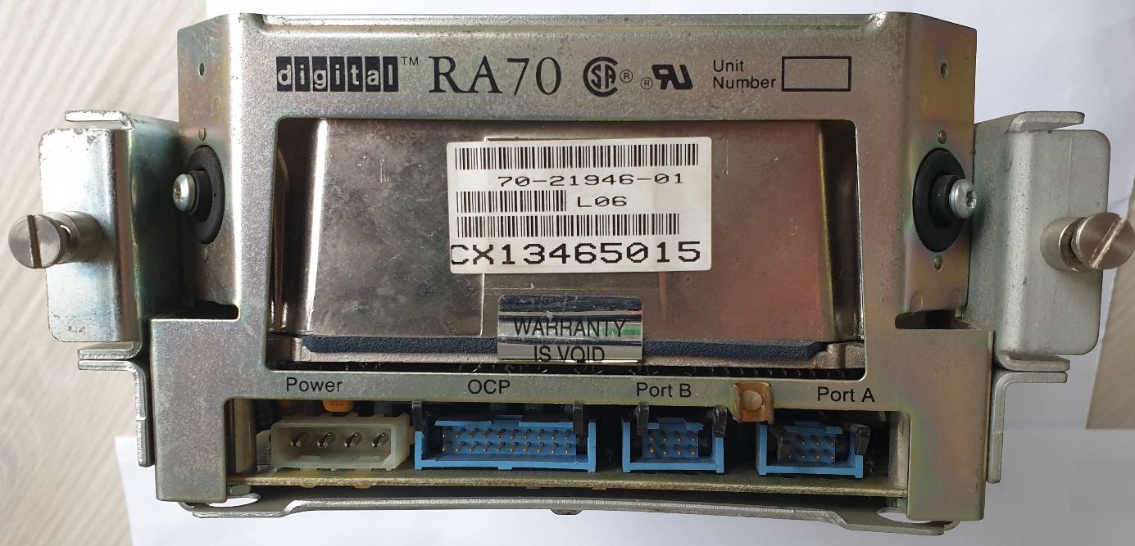

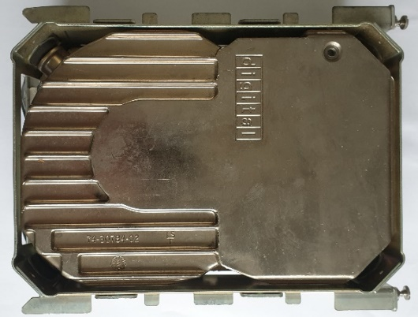

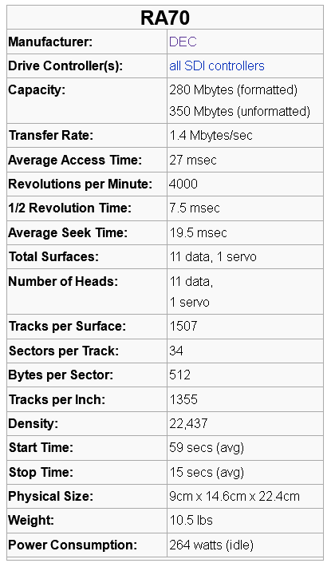

**MFM**\* Type ST412

Hard drive 5 ¼” MFM*, HH with black face, Seagate ST-225. MFM type: ST412. Two connectors: 34 pins for control and 20 pins for data. Σ=> 54 pin. Green diode..

<https://stason.org/TULARC/pc/hard-drives-hdd/seagate/ST225-21MB-5-25-HH-MFM-ST412.html>

*)The common name of the interface is MFM. The correct name is ST-506 or ST412. Derived from the disk model. It became the standard. There was no such thing as an "RLL disk or MFM disk". The disk type (MFM or RLL) was determined solely by the low-level format, and this in turn depended on the disk controller card. Theoretically, any ST-506 (two-wire) drive can be formatted using an MFM or RLL controller

[MFM](https://www.redhill.net.au/o/glos.html#rll) - **M**odified **F**requency **M**odulation is the successor FM.

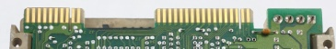RLL - **R**un **L**ength **L**imited.

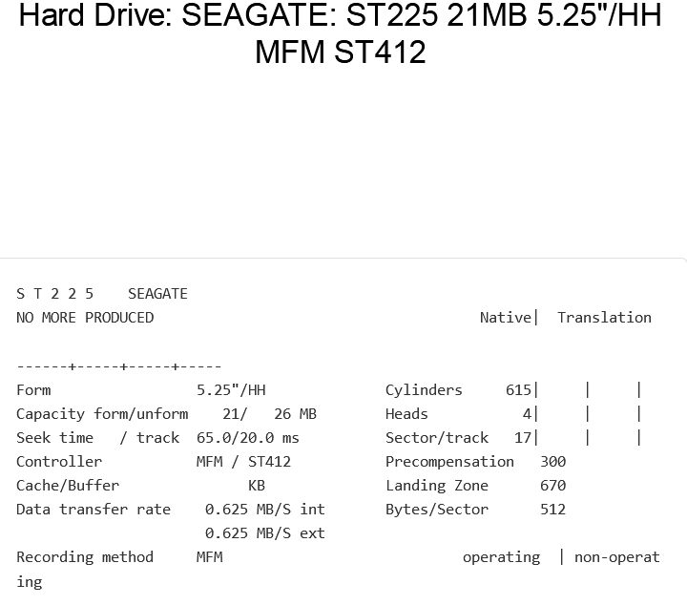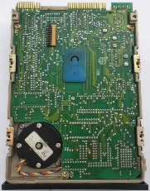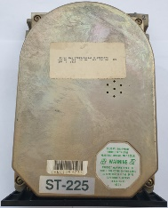

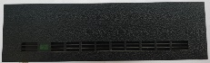

**SASI**

5 ¼” SASI hard drive, Xebec 4020 installed in Amstrad PC1640\PC1520.

**S**hugart **A**ssociates **S**ystem **I**nterface. Two connectors: 2x23 + 2x2 pins for data and 4 pins for power. Σ=> 50 pins. Red LED

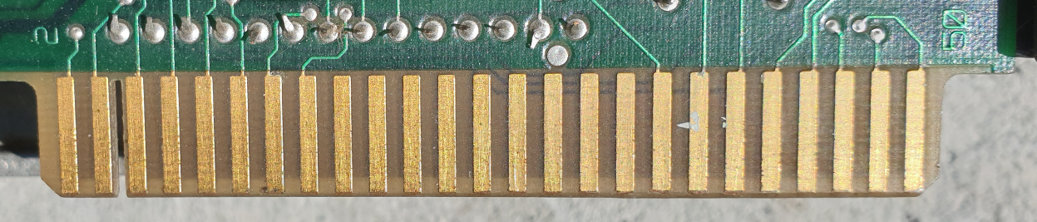

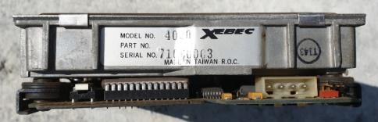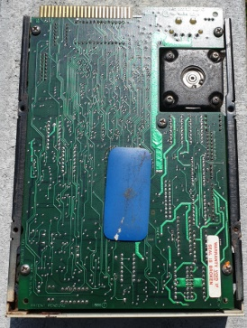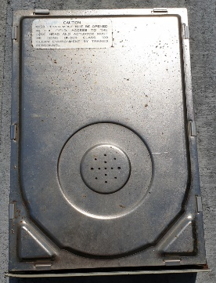

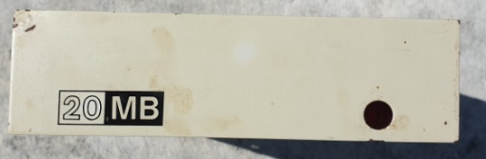

**ESDI**

5 ¼ Micropoli 1568 Full High

2x17 pins + 2x20 pins + 2x4 pins Σ=> 82 pins Power supply 4 pins.

<https://stason.org/TULARC/pc/hard-drives-hdd/micropolis/1568-15-702MB-5-25-FH-ESDI.html>

"**E**nhanced **S**mall **D**evice **I**nterface". It was a hard drive interface standard developed in 1983 by Control Data Corporation. ESDI offered several improvements over the earlier ST506 standard, including:

* Higher data throughput: ESDI could transmit data at up to 10 Mbps, while the ST506 was limited to 5 Mbps.
* Larger disk capacity: ESDI supported disks up to 1 GB, while ST506 supported disks up to 640 MB.
* Improved Reliability: ESDI has introduced several features to improve data reliability, such as error correction coding.

ESDI was a popular hard drive interface standard in the 1980s and early 1990s. However, it was replaced by newer standards such as IDE and SCSI, which offered even higher performance and capacity.

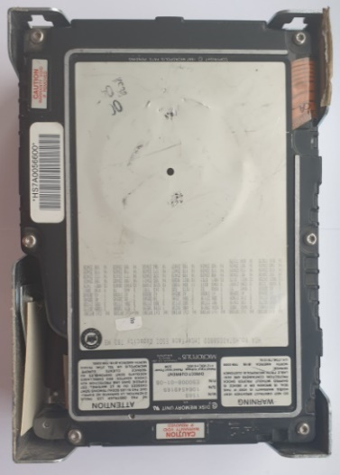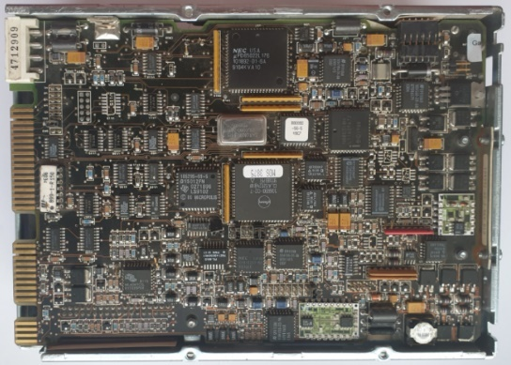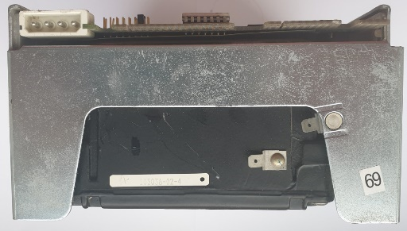

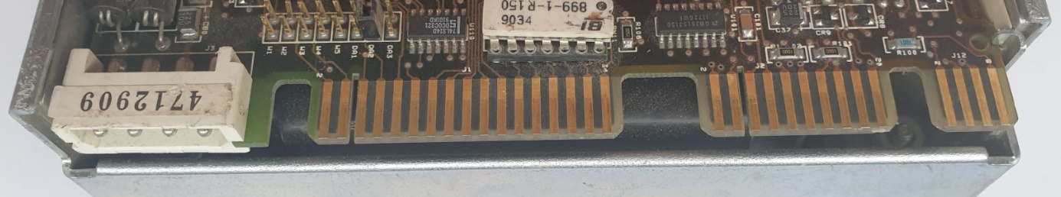

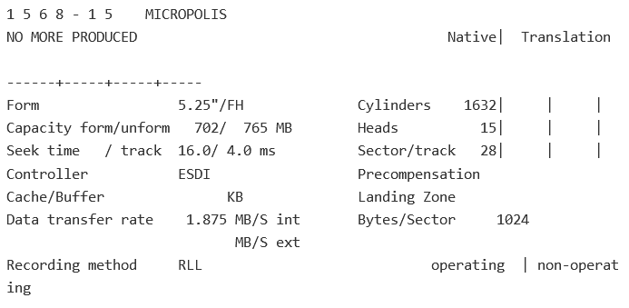

**SCSI**-I 50 pins

DISK 5 ¼” SCSI 50, FH with black face, Seagate ST4702N. Two cables: 50 pin data and 4 pins for power. Data Σ=> 50 pin. Red LED.

<https://stason.org/TULARC/pc/hard-drives-hdd/seagate/ST4702N-WREN-601MB-5-25-FH-SCSI1-SE.html>

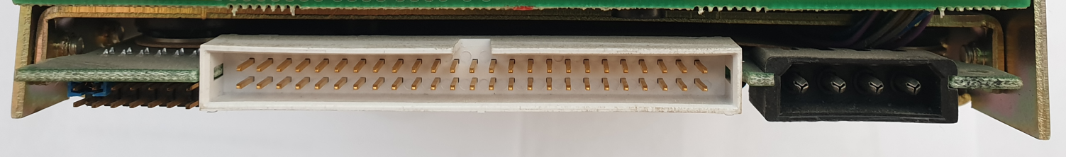

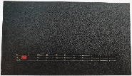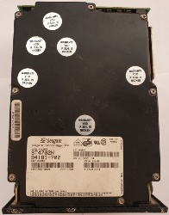

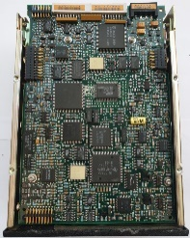

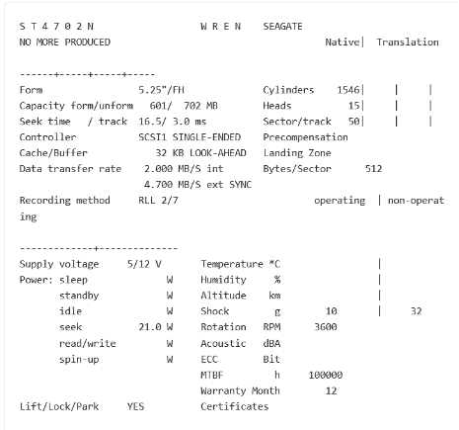

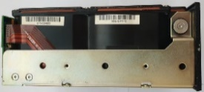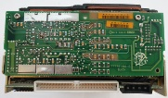

**IDE**

Disc 5 ¼” Quantum Bigfoot 4320AT.

Two cables: 40 pin data and 4 pin for power. Data Σ=> 40 pin. And jumper pins.

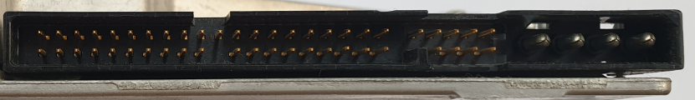

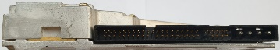

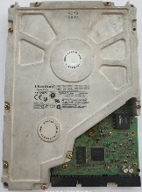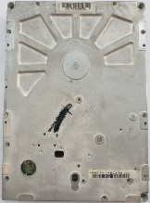

**MFM** (connector\Interface not edge.)

Disc 5 ¼” MFM, HH with black face, Tandon TM 252. MFM type: ST506. Two cables: 2x10 = 20 pin and 2x17 = 34pin Σ => 54 pin. Red LED. Mounted, for example, in TECMAR together with Q-PAK. The first external drive for Mac.

<https://stason.org/TULARC/pc/hard-drives-hdd/tandon/TM252-10MB-5-25-HH-MFM-ST506.html>

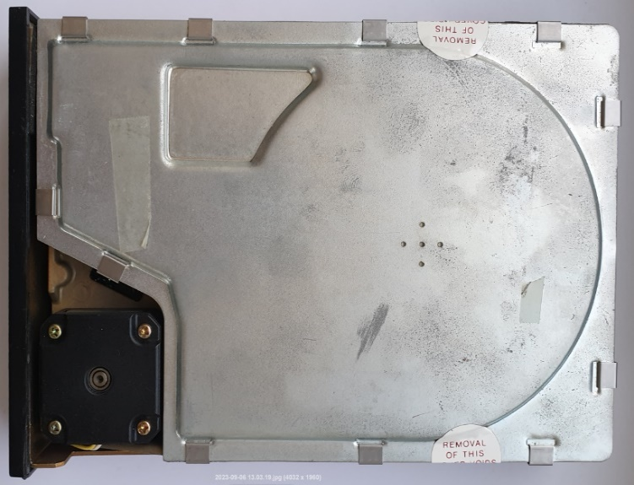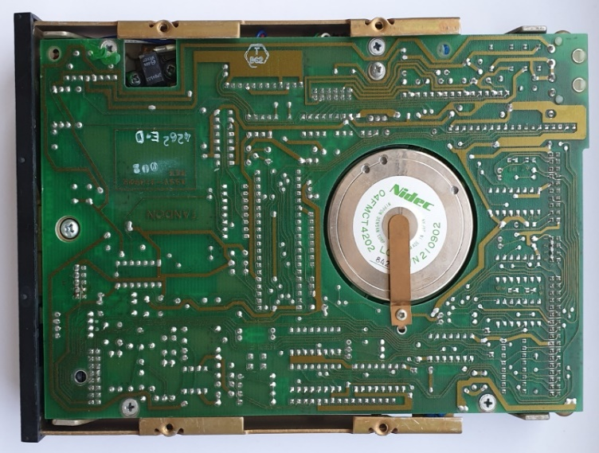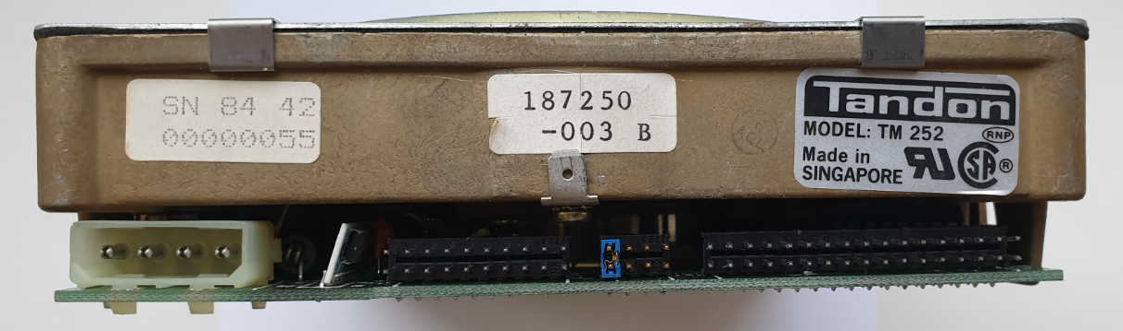

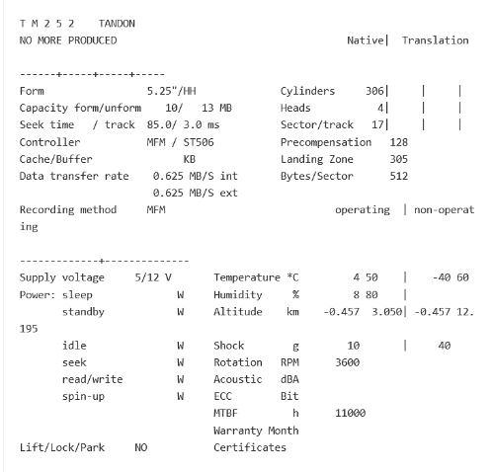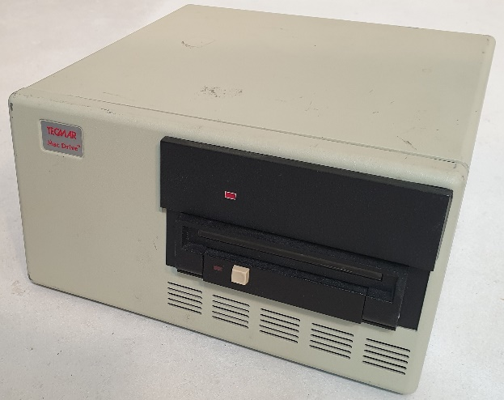

**Apple Widget** 10 MB 2x17 pins. Patent Apple for Lisa 2 Computer. 1983.

5 ¼” Full High.

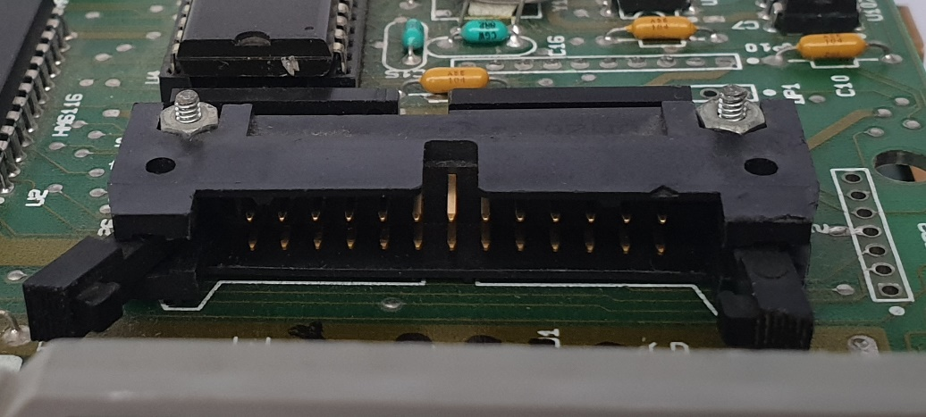

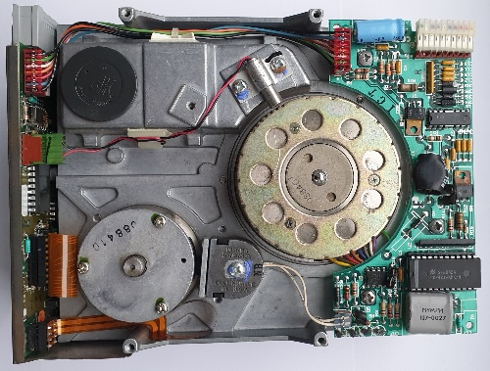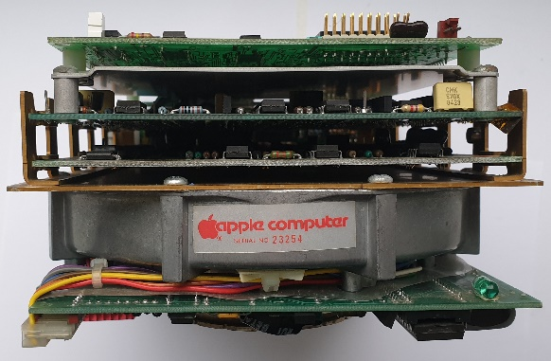

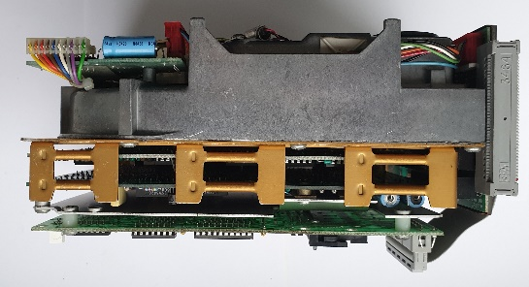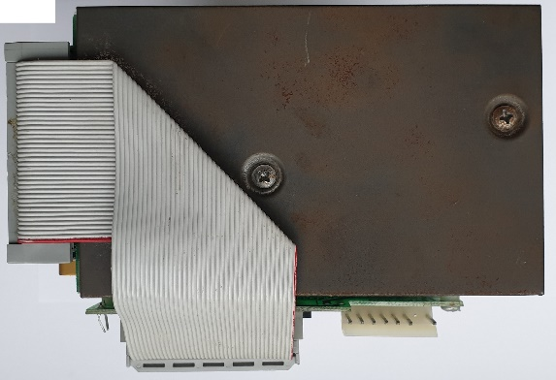

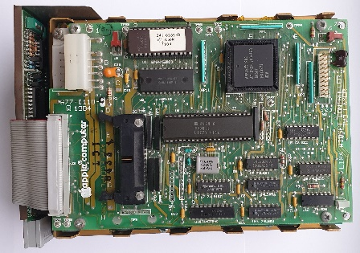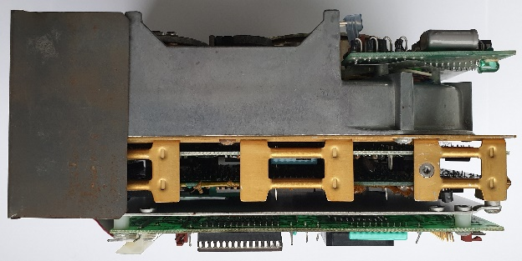

**Size 3 ½”**

**ESDI** 72 pins.

3 ½” ESDI HH DISK, HDD from IBM PS. IBM WD-387, PN:6128257 FRU:6128294. 60MB. 2x36 pins. Σ=>72 pins. Yellow LED.

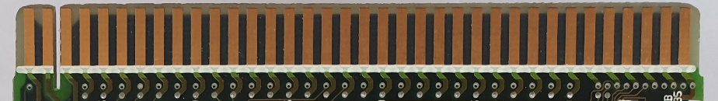

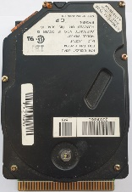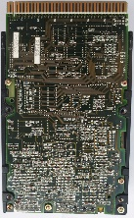

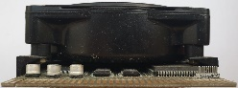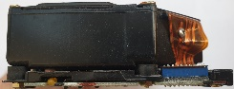

**ESDI** 44 pins

3 ½” ESDI HDD from IBM PS. WDL-330P, PN:6128242 FRU:6128279. 30MB. 2x22. Σ=> 44 pins. Without diode.

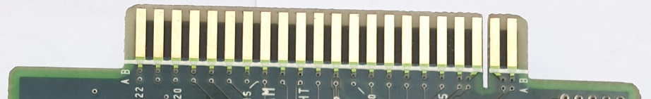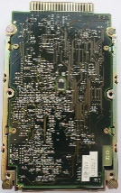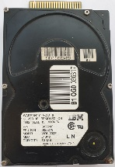

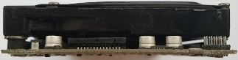

**ESDI** as MFM

NEC D3661 ESDI HH. Two cables: 2x10 pin + 2x17 pin for power. Separate power supply 4 pins. Σ=> 54 pin.

<https://stason.org/TULARC/pc/hard-drives-hdd/nec/D3661-113MB-3-5-HH-ESDI.html>

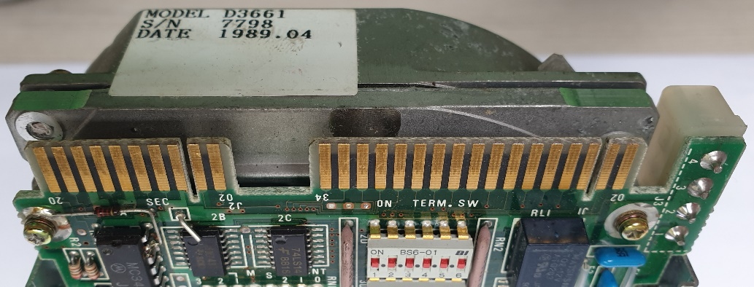

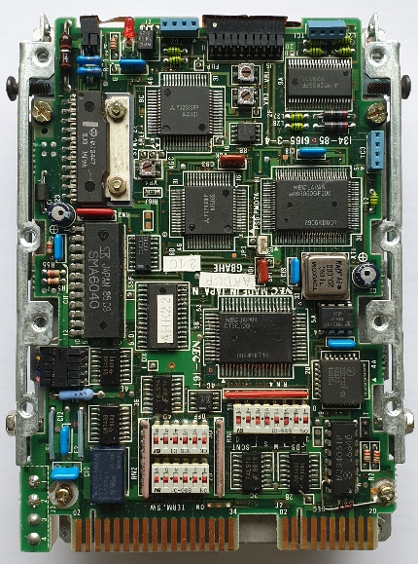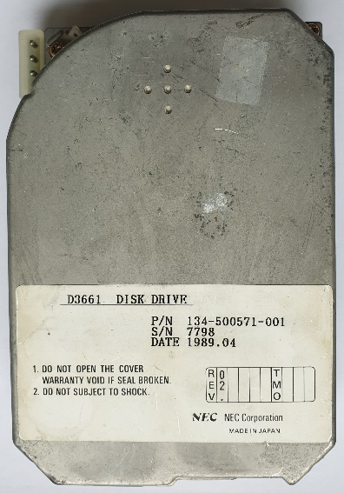

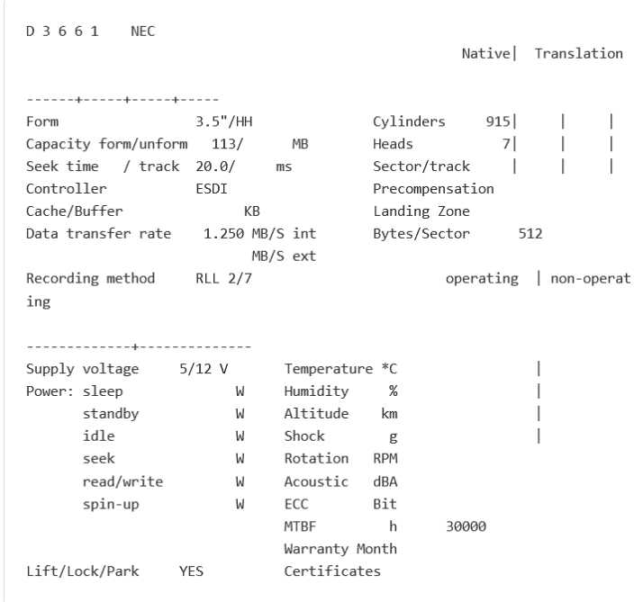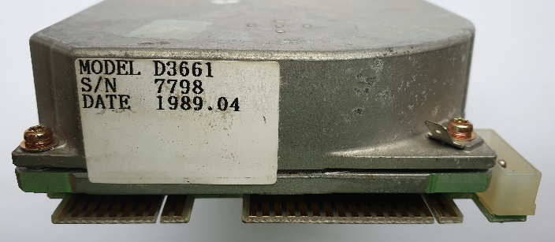

**MFM** Type ST506

MFM HH Kyocera KC-20B. 21MB. MFM type: ST506. Two cables: 2x10 pin + 2x17 pin for power. Separate power supply 4 pins. Σ=> 54 pin. Green diode.

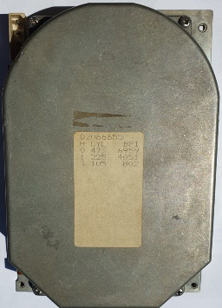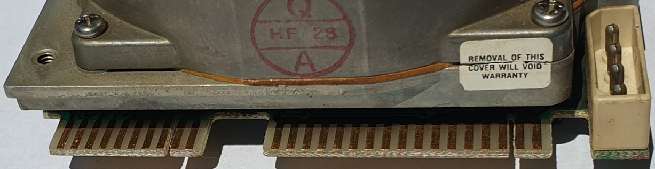<https://stason.org/TULARC/pc/hard-drives-hdd/kyocera/KC-20B-21MB-3-5-HH-MFM-ST506.html>

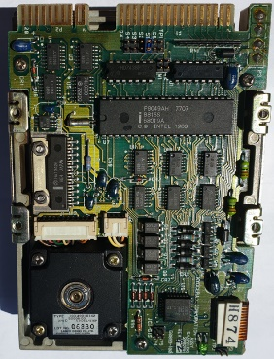

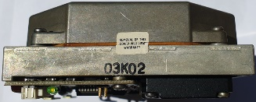

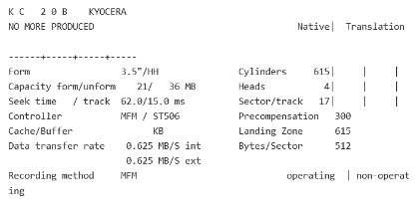

**ATA/IDE**.

 3 ½” ATA/IDE DISK. 40 pins + 9 configuration jumpers. Separate power supply 4 pins. Σ=> 40+9 pins.

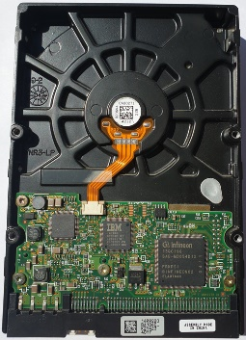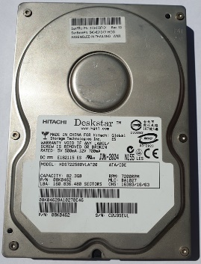

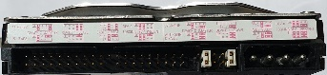

**MFM** Type ST412 with RLL

3 ½” disc ST-157R Seagate RLL* - Run Length Limited. Type ST412. Two cables: 2x10 pins + 2x17 pin for power. Separate power supply 4 pins. Σ=> 54 pins.

<https://stason.org/TULARC/pc/hard-drives-hdd/seagate/ST157R-0-49MB-3-5-HH-RLL-ST412.html>

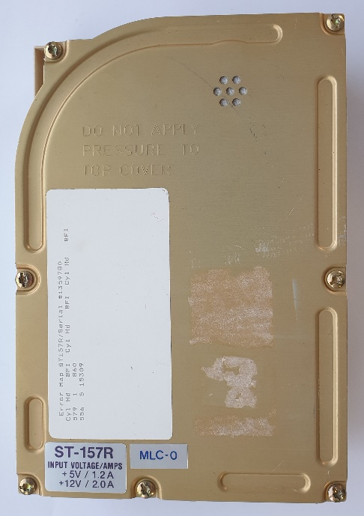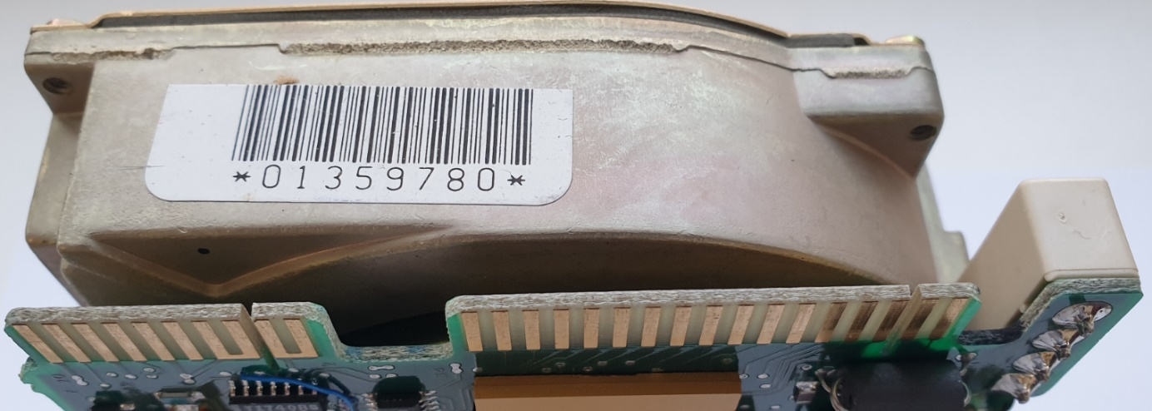

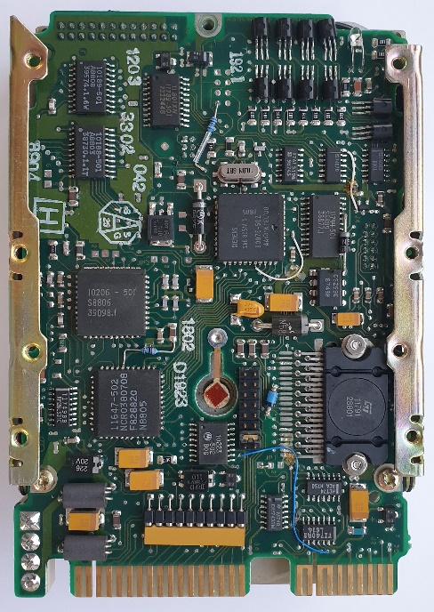

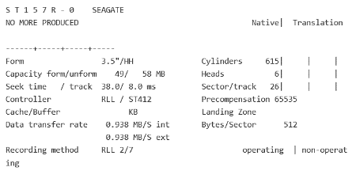

**JVC Disc 3 ½” unknow**

3 ½” disc. Standard - unknown. JVC JD-3824R00-1. Σ=>26 pins. There are no equivalents \ substitutes \ substitutes. Mounted in Epson PX-16, Epson LT, Epson Q150A, Sharp PC-7200. <https://electrickery.nl/comp/divcomp/26pinHD.html>

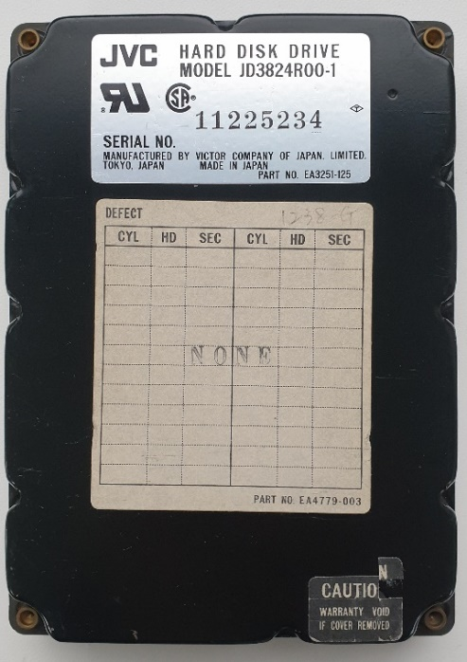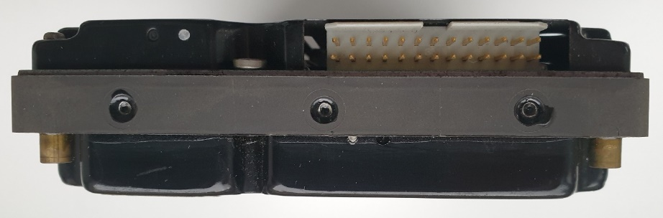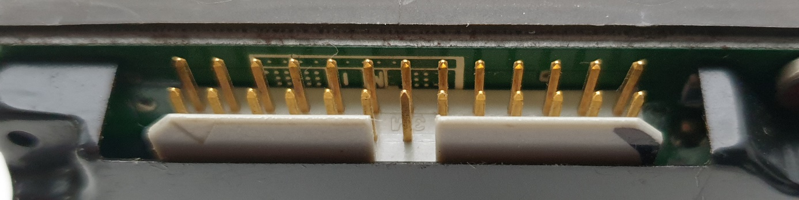

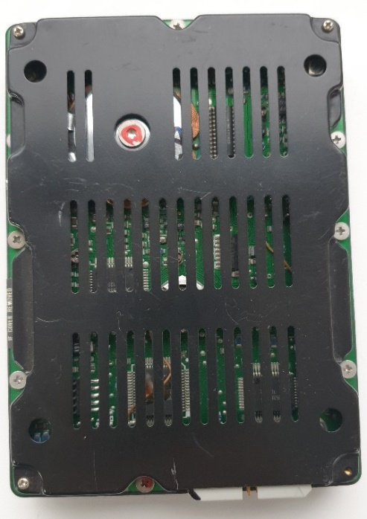

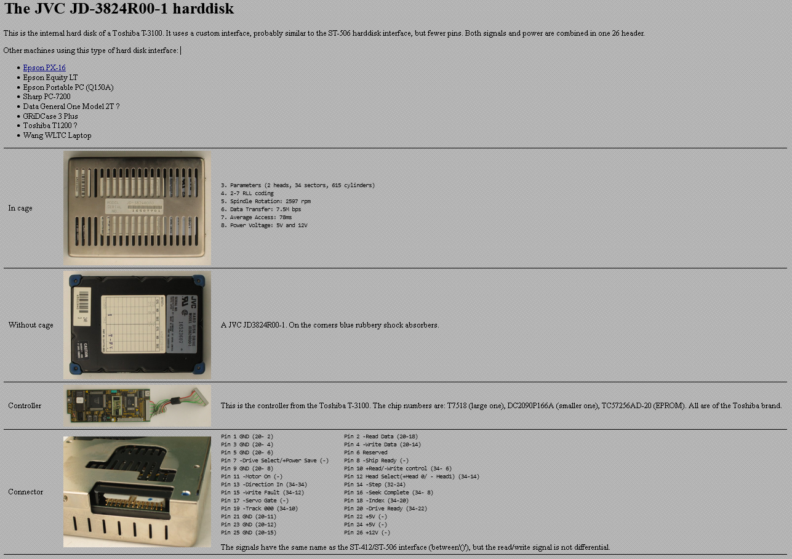

**SCSI - patent for Apple 2x17 pins.**

Conner CP3045 (Apple Hard disk 40SC)

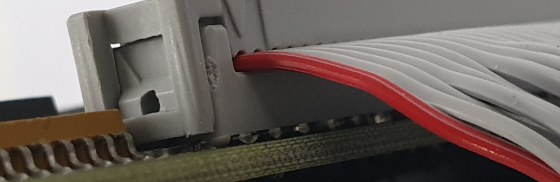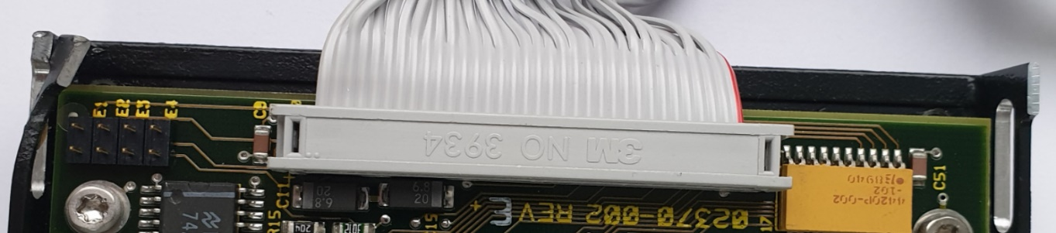Only 2x17 pins = 34 pins. The connector and number of pins are the same as in the Apple Lisa disk and as in the “*strange*” disk 5 ¾”. A drive designed specifically for Apple PowerBook. Known by Apple as "Hard Disk 40SC". It has a patented SCSI connector. The cable is permanently connected to the disk. There is no power socket. Only 2x17 pins cable. SCSI patent for Apple.

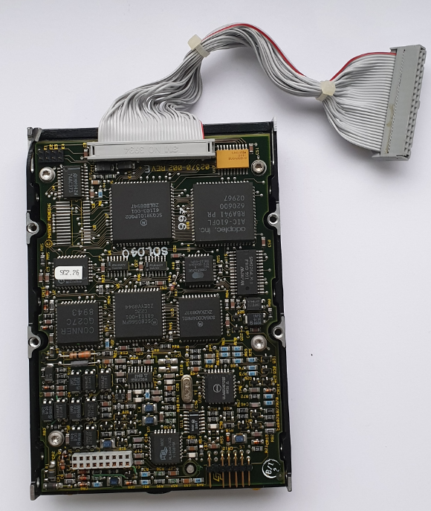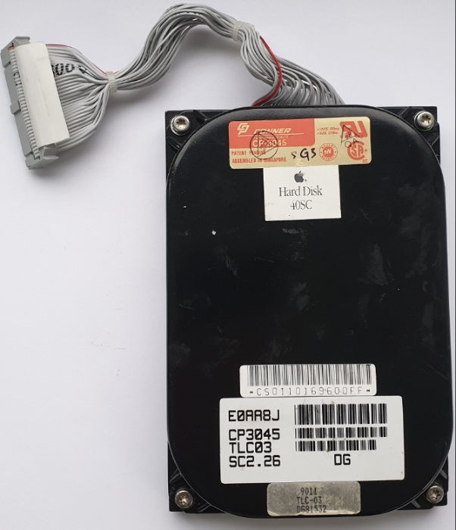

**DSSI**

DEC Model RF35 3½” Data 2x25=50 pins. Power 5 pins. Data Σ=> 50 pin.

DSSI **D**igital **S**torage **S**ystems **I**nterconnect.

<https://gunkies.org/wiki/RF35>

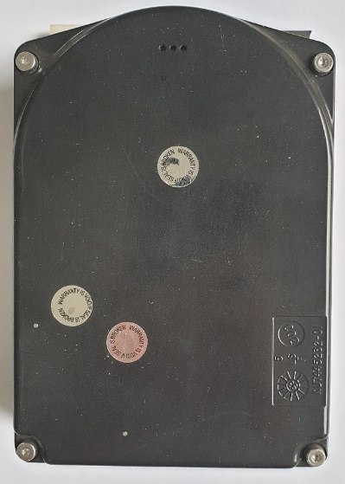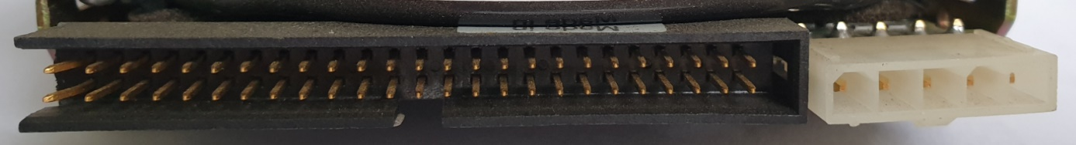

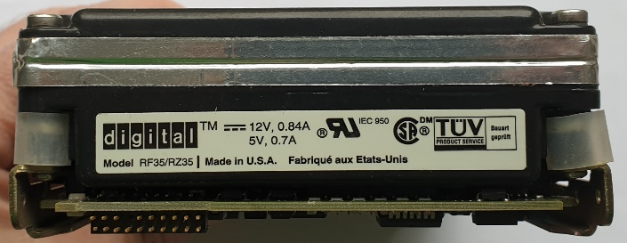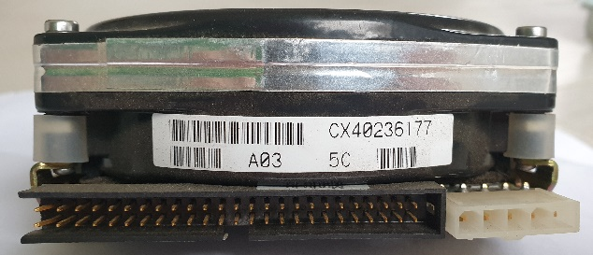

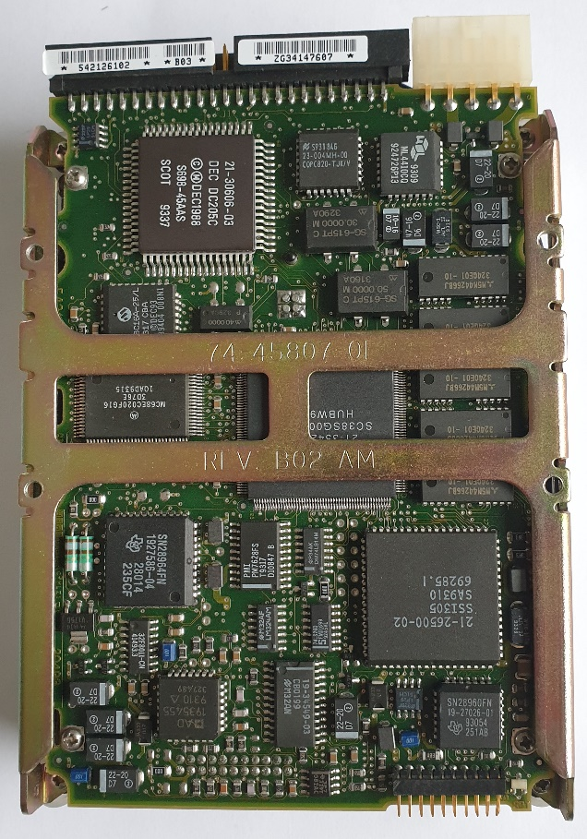

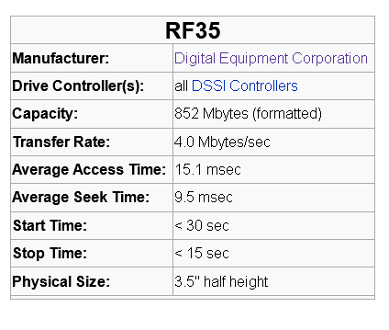

**SCSI-I** 50 pins.

Quantum Fireball ST. 2x25 pins. Power 4 pins. Σ=> 50 pins.



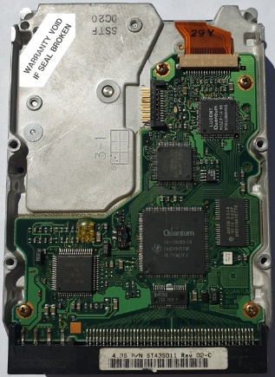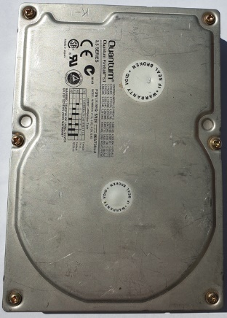

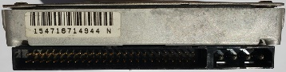

**SCSI** 68 pins.

3 ½” SCSI 68 Quantum Viking disc. 2x20 pins. 2x6 pins configuration jumpers. Power supply separately 4 pins. Σ=> 40 + 12 pins.

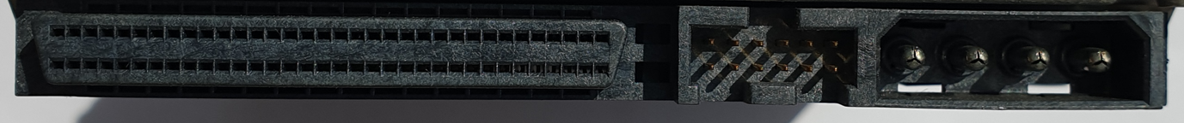

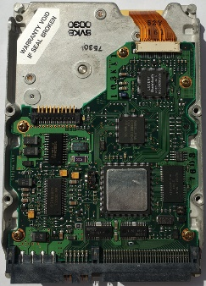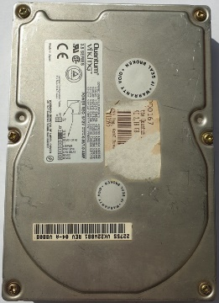

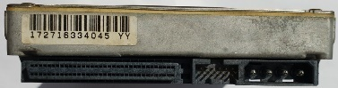

**SCA** -UltraSCSI 3 80 pins. **Single Connector Attachment.**

3 ½” SCA drive = Ultra 3 SCSI 80 IBM Ultrastar. 2x40 pins. Σ=> 80 pins.

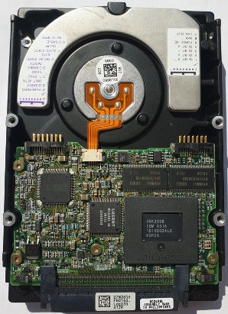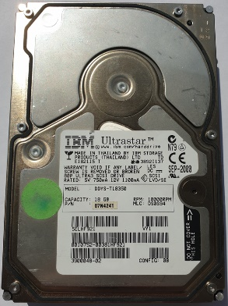

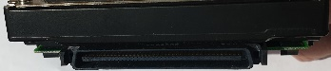

**FC** Fibre Channel.

Seagate Cheetah.Pins 2x20 Σ=> 40 pin.

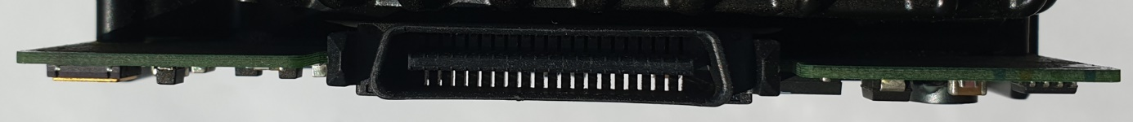

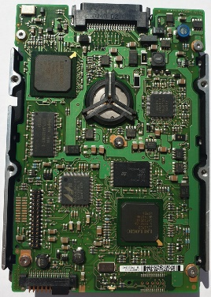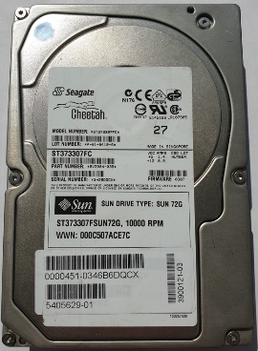

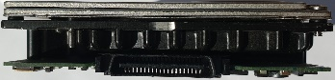

**SSA** (**S**erial **S**torage **A**rchitecture)

Drive 3 ½” Pins : 2x3 + 2x3 + 2x5 + 2x8 = Σ=> 38 pins.

and on the other side 2x16 pins.

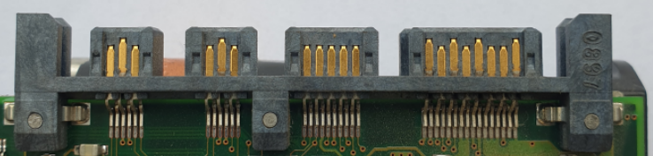

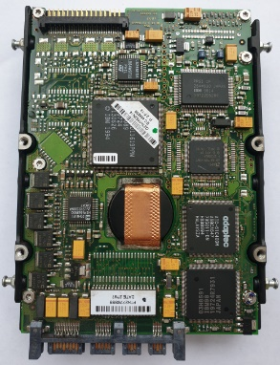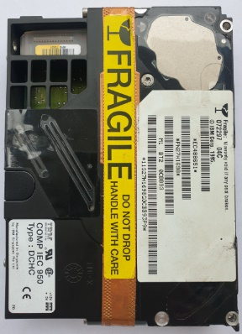

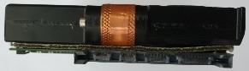

**SATA** Serial ATA.

Drive 3 ½” Pins : 15 + 7 + 9 jumpers + 4 pins for power.

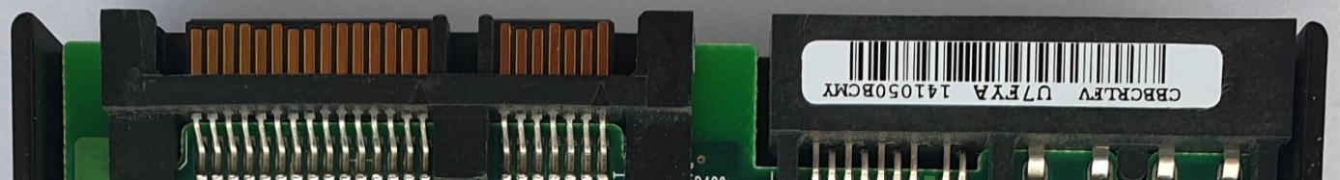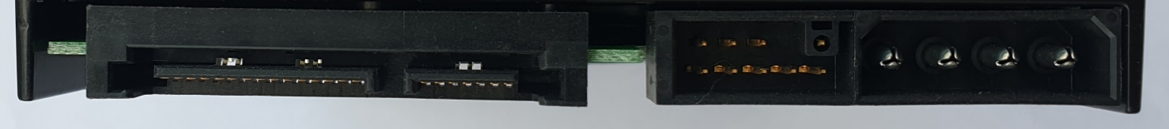

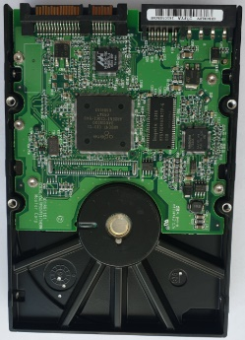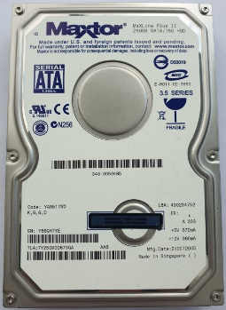

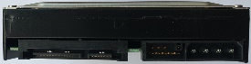

**SATA** Serial ATA.

Drive 3 ½” Pins : 15 + 7 + 9 jumpers + 4 pins for power.

Low profile. Thickness = 2 cm.

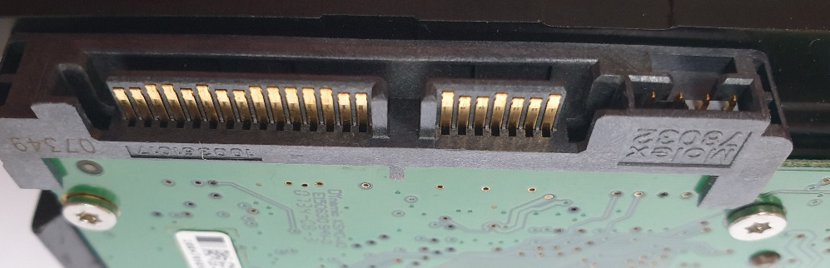

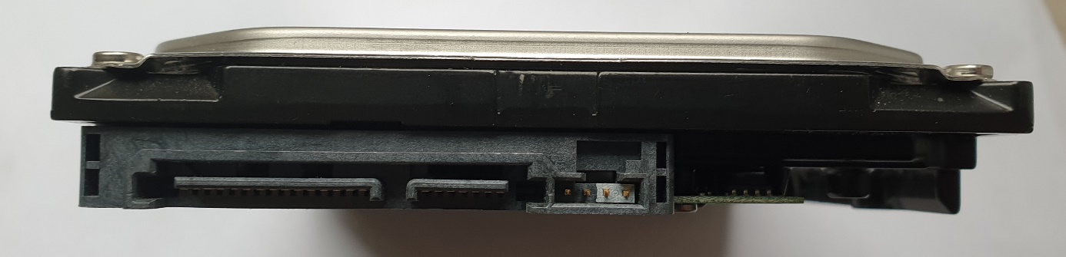

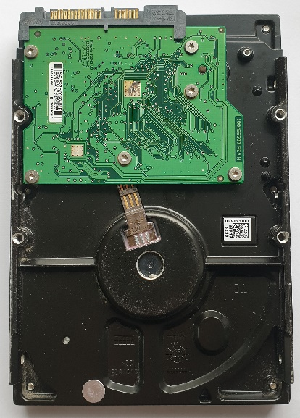

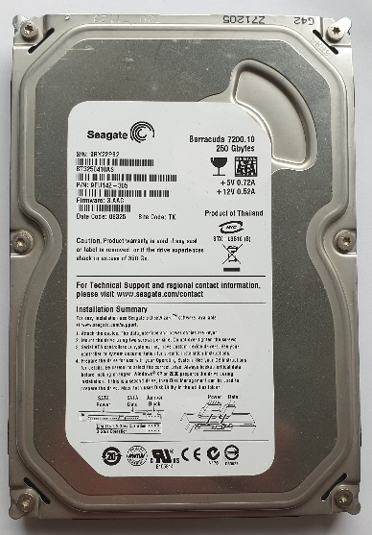

**SAS** **S**erial **A**ttached **S**torage.

Drive 3 ½” Pins : 15 + 7 + 4 jumpers.



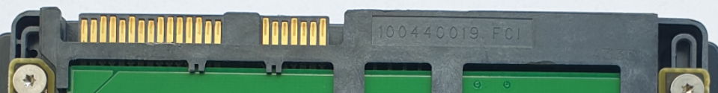

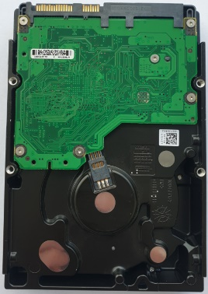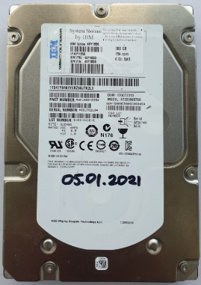

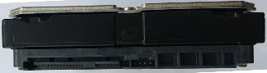

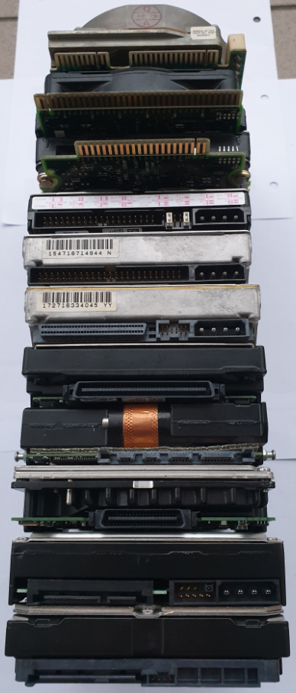

* **MFM ST-412**
* **ESDI IBM PS/2**
* **MFM IBM ST-506**
* **IDE \ EIDE**
* **SCSI 50**
* **SCSI 68**
* **SCSI 80**
* **SSA**
* **FC**
* **SATA**
* **SAS**

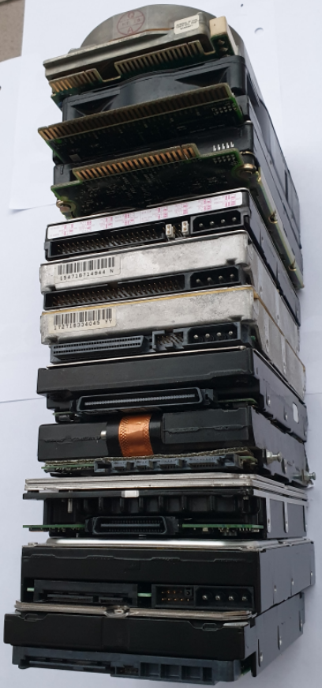

* **MFM ST-412**
* **ESDI IBM PS/2**
* **MFM IBM ST-506**
* **IDE/ATA**
* **SCSI 50**
* **SCSI 68**
* **SCSI 80**
* **SSA**
* **FC**
* **SATA**
* **SAS**

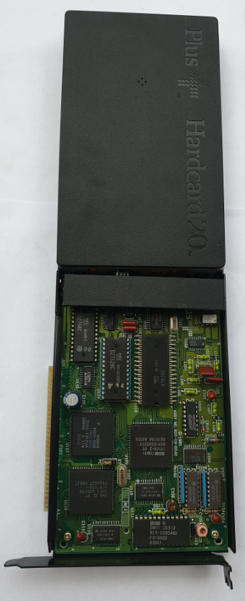**Size 3 ½” ISA**

Drive 3 ½”ISA Slot, HardCard 20 PLUS. That is, the disk on the ISA card. **I**ndustry **S**tandard **A**rchitecture.

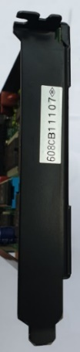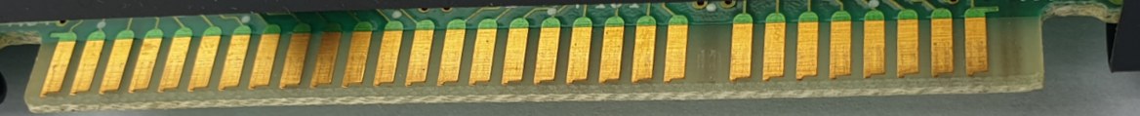

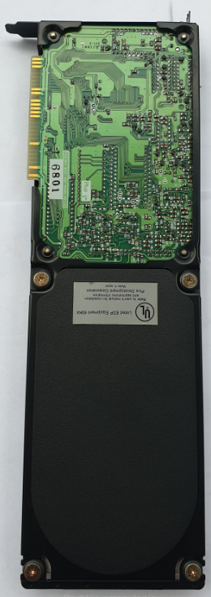

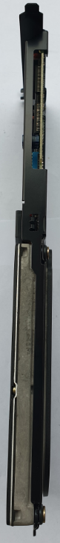

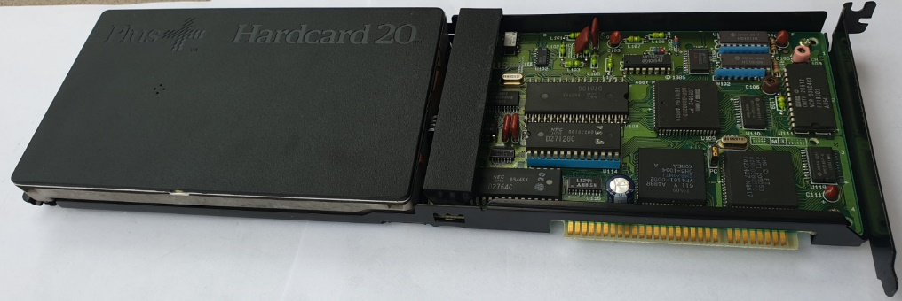

**Size 2 ½”**

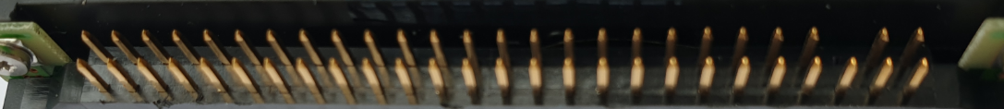**ESDI** **E**nhanced **S**mall **D**isk **I**nterface.

Drive 2 ½” IBM WD-W2160D, **h=17mm**, 2x24 pins + 2x2 pins = 48+4 Σ=> 52 pins.

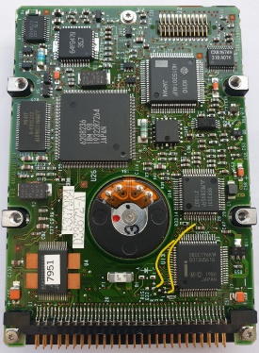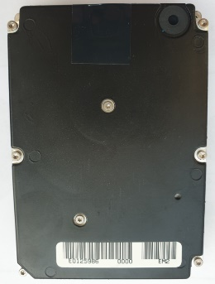



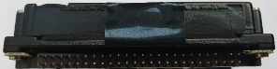

**ESDI** - caddy IBM WD-W2160D, **h=18mm**, case\caddy for the above-mentioned disk. 2x30 pins Σ=> 60 pins.

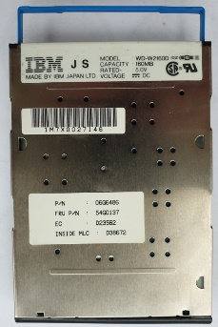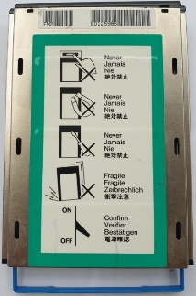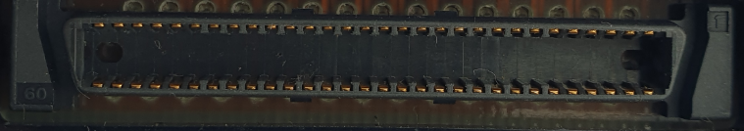

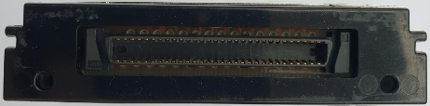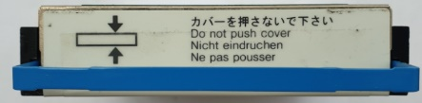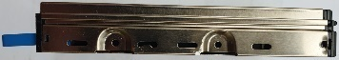

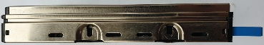

**SCSI** Apple (IBM)

Drive 2 ½” WDS-280 **h=17mm**, 2x20 pins + 2x4 pins Σ=> 48 pins.

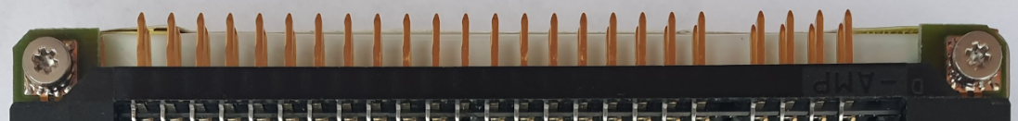

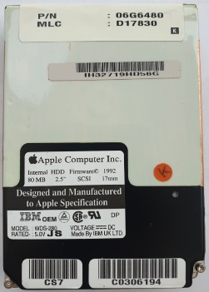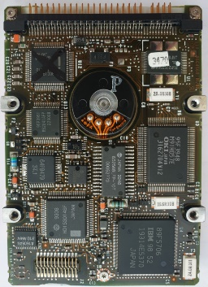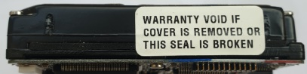

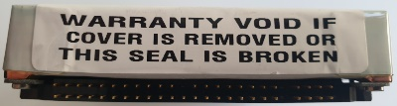

**IDE** thick

TOSHIBA MK2720FC **h=18.5mm**, 2x22 pins + 2x2 pins Σ=> 48 pins.

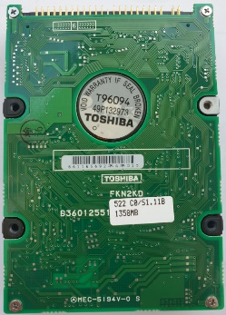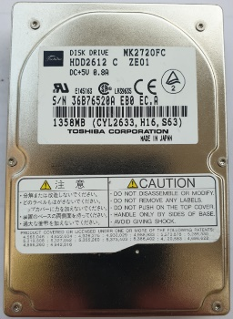

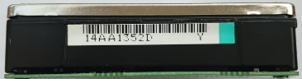

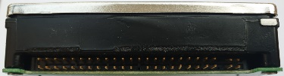

**IDE**

h=9.5mm. 2x22 pins + 2x2 pins Σ=> 48 pins.

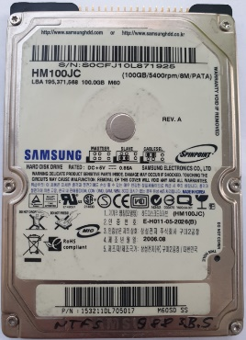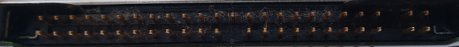

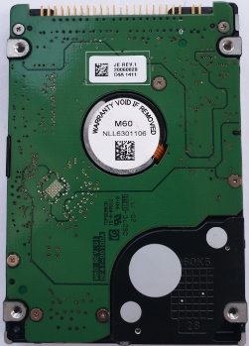



**IDE**. Połowa długości. Grubość h=9.5mm. 2x22 piny + 2x2 piny Σ=> 48 pin.

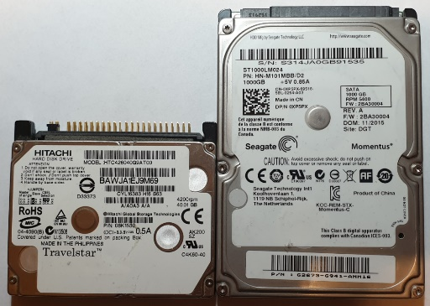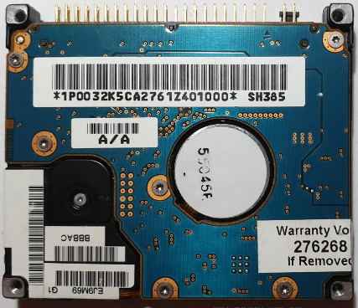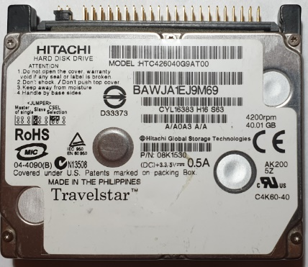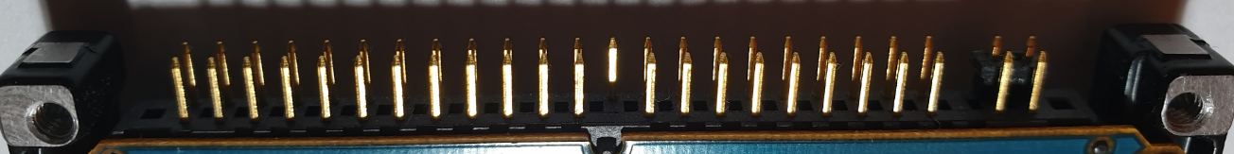

**SCSI U320**. ST936701LC. h=14.5mm. 2x40 pin. Σ=> 80 pin.

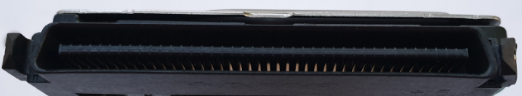

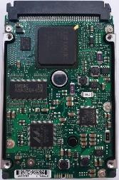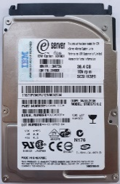

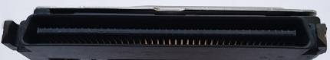

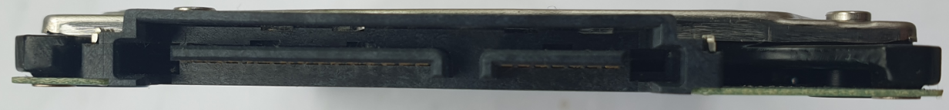**SATA.** Hitachi. Grubość h=7mm. Pin 15+7. Σ=> 22 pin.

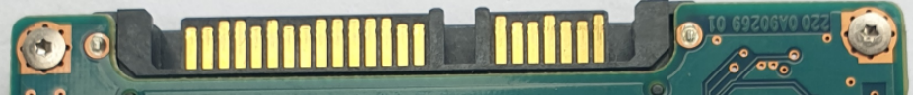

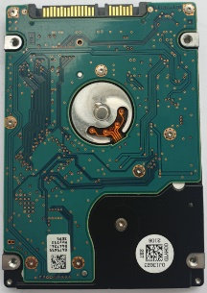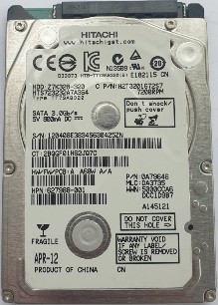

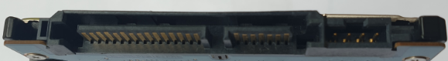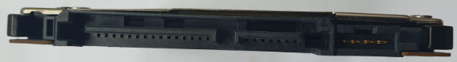**SATA. *SSHD.*** Hitachi. Grubość h=7mm. Pin 15+7. Σ=> 22 pin.

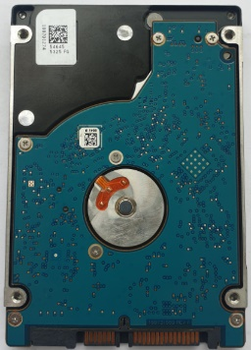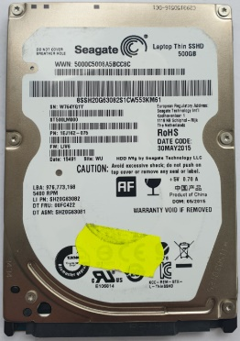

**SATA. SSD.** Intel. Grubość h=7mm. Pin 15+7. Σ=> 22 pin.

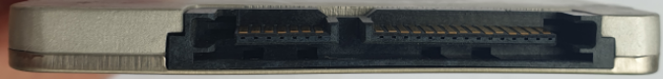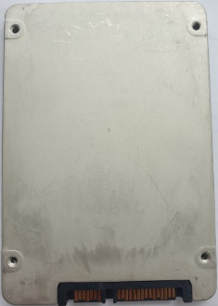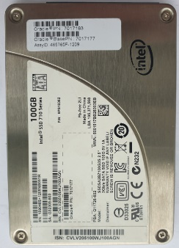

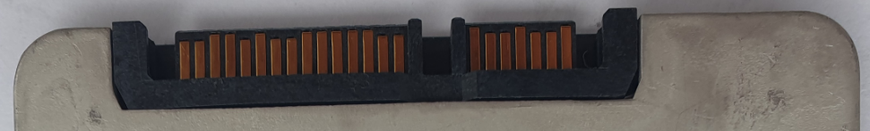

**SATA. *SSSE*****Samsung Solid State Enterprise - hybryda.** Intel. Grubość h=9.5mm.

Pin 15+7. Σ=> 22 pin.

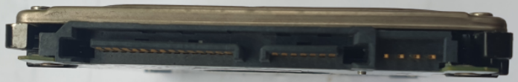

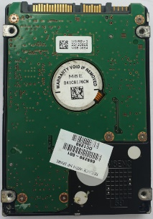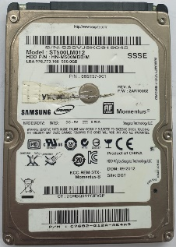

**SATA**. 8MB buffer. Toshiba. Grubość h=9.5mm. Pin 15+7. Σ=> 22 pin.

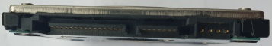

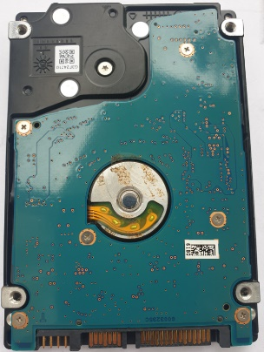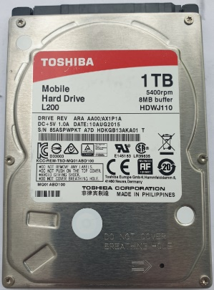

**SATA**. Toshiba. Grubość h=14.5mm. Pin 15+7. Σ=> 22 pin.

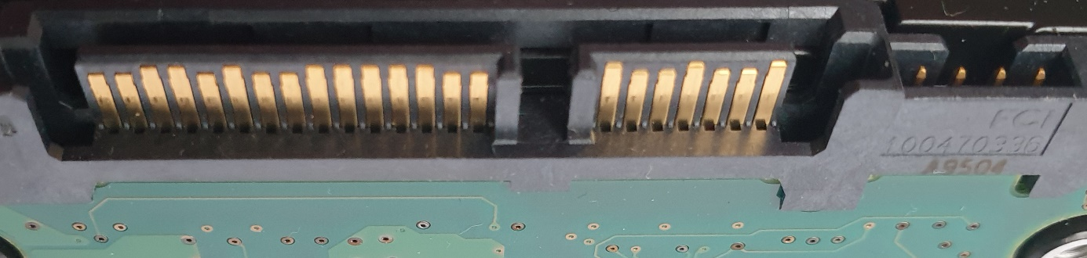

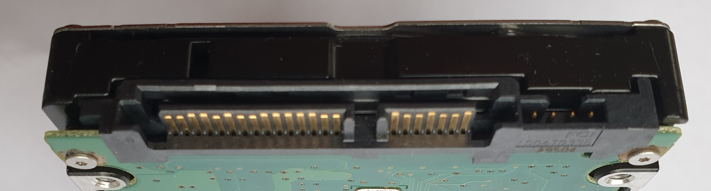

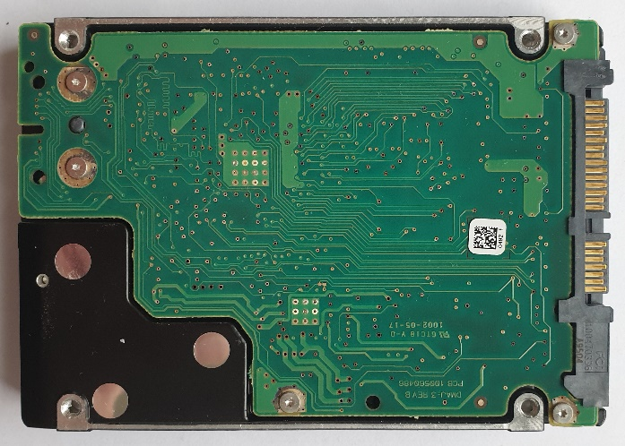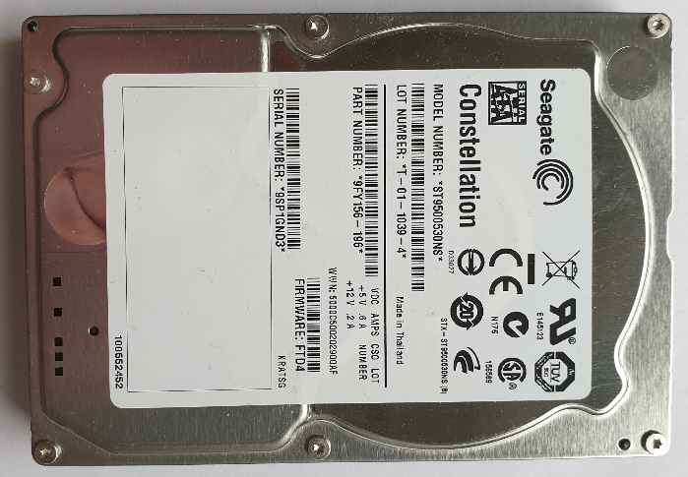

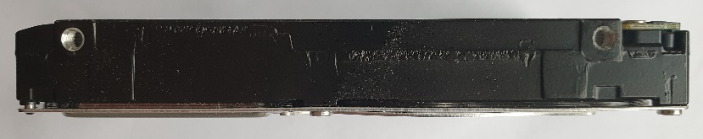

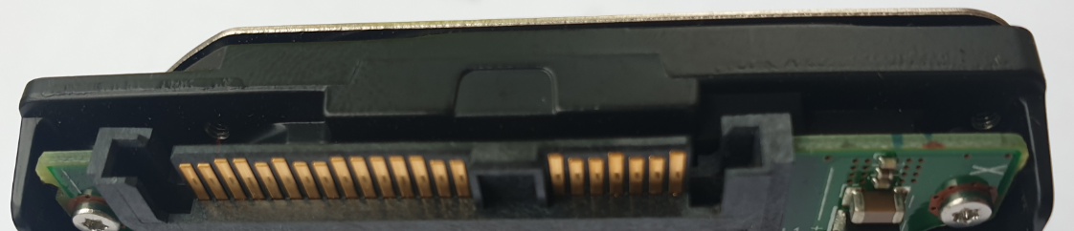**SAS.** Sun\Fujitsu. Grubość h=14.5mm. Pin 15+7. Σ=> 22 pin.

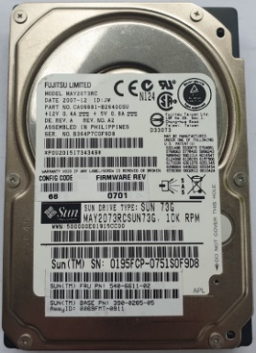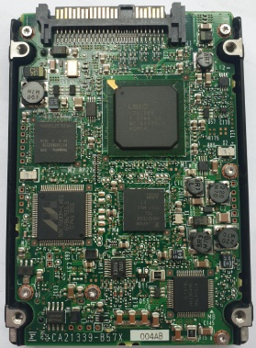

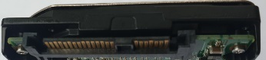

**USB.** Western Digital. Grubość h=14.5mm. Pin 5+4+6. Σ=> 15 pin.

Dioda biała.

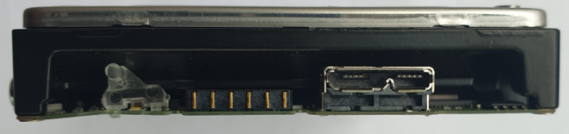

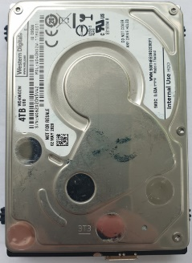

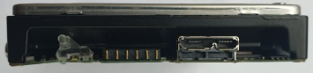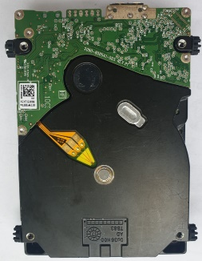

**SATA. RDX** IBM.

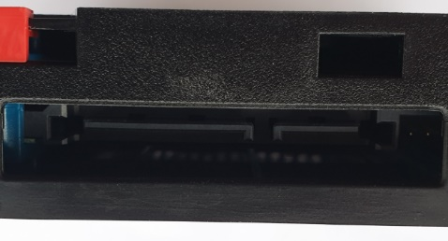

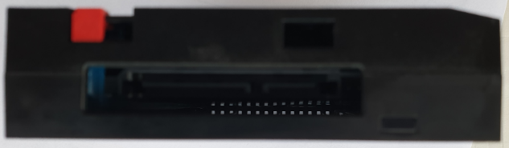

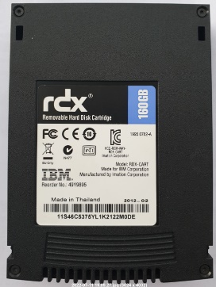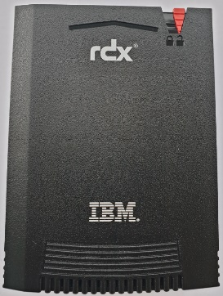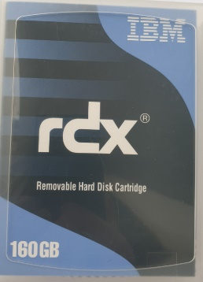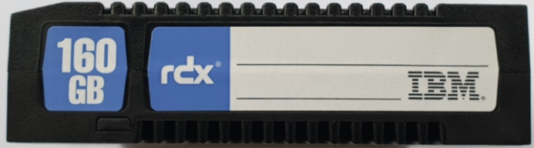

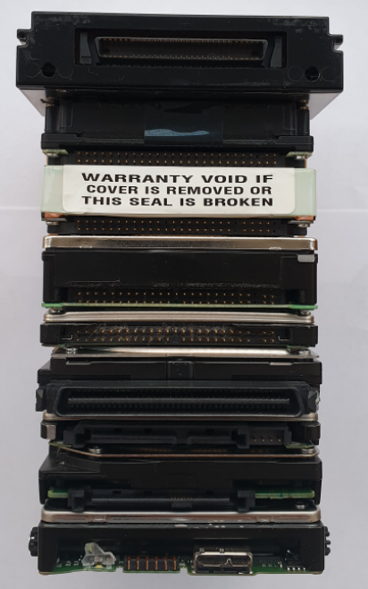

<- caddy do n\w HDD ESDI

<- ESDI

<- SCSI

<- IDE *Toshiba GRUBY*

<- IDE *„zwykły”*

<- SCSI U320

<- SATA

<- SAS

<- USB

**ROZMIAR 1.8”**

DYSK 1.8” PCMCIA CF+ Typ II 340MB 3600 rpm IBM. PN: 22L0046, Pin 2x25. Σ=> 50 pin.

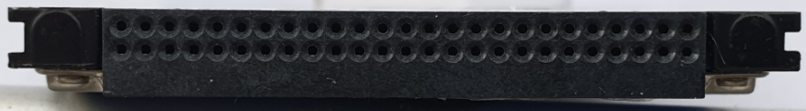

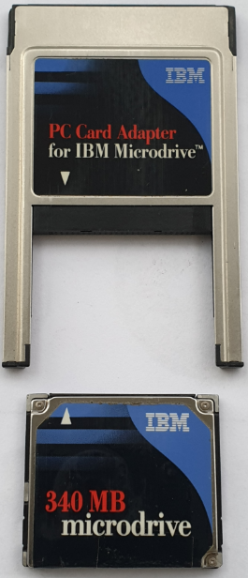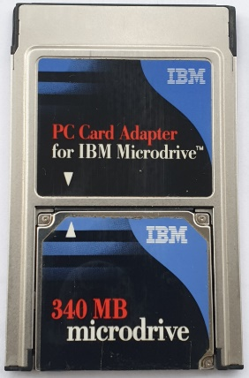

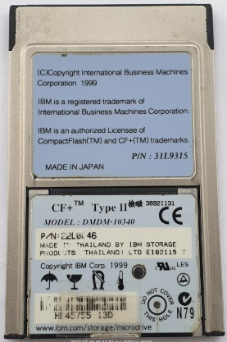

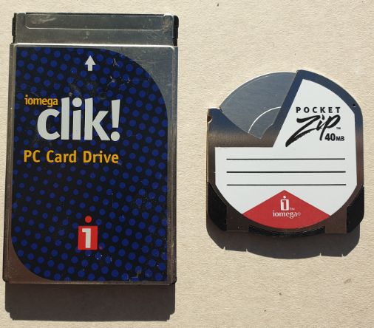DYSK 1.8” PCMCIA iOmega Clik! ZIP 40MB oraz dysk microdrive PCMCIA Typ I.

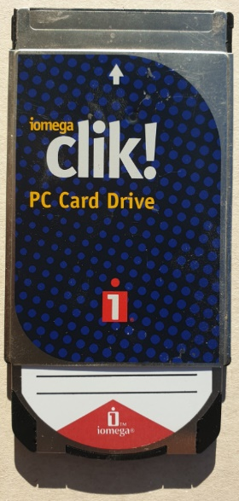

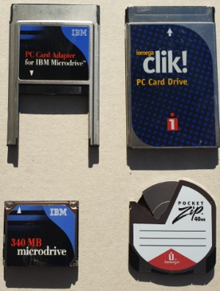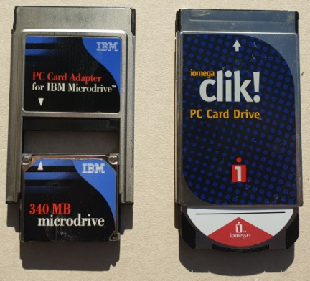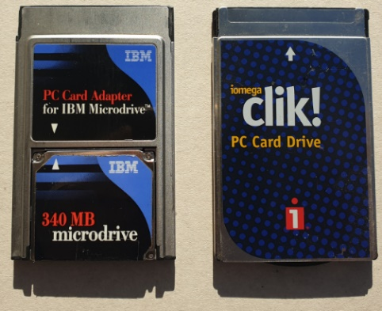

PCMCIA to skrót od Personal Computer Memory Card International Association

Typ I: 16-bitowy. Grubość konfiguracji 3,3 mm (0,13 cala)

Typ II: 16-bitowy lub 32-bitowy. Grubość konfiguracji 5,0 mm (0,20 cala)

Typ III: 16-bitowy lub 32-bitowy. Grubość konfiguracji 10,5 mm (0,41 cala)

Typ IV: 16 milimetrów (0,63 cala).

DYSK 1.8” PCMCIA IBM 2x34. Σ=> 68 pin. PCMCIA Typ IV.

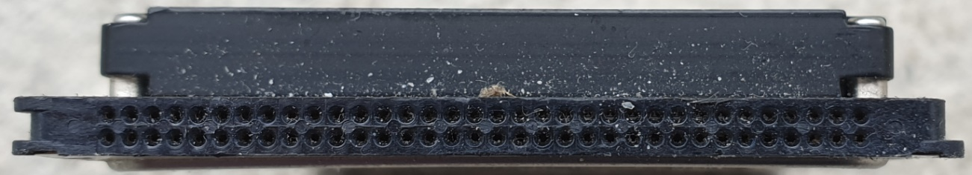Wysokość 16 mm.

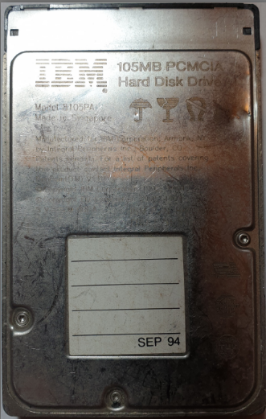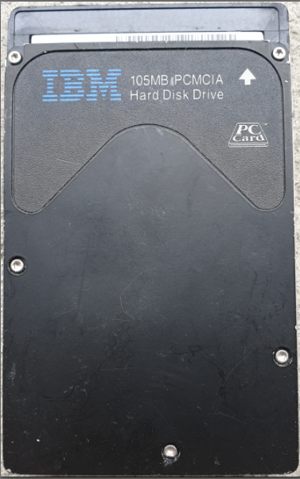

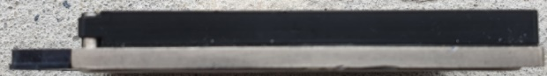

DYSK 1.8” Toshiba PATA 2x25. Σ=> 50 pin.

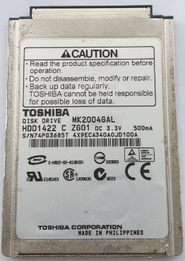Wysokość 8 mm

DYSK 1.8” Toshiba **m**SATA 7+7+2. Σ=> 16 pin.

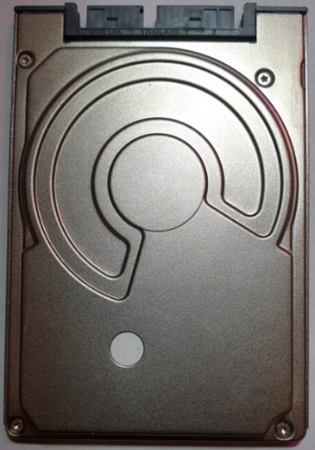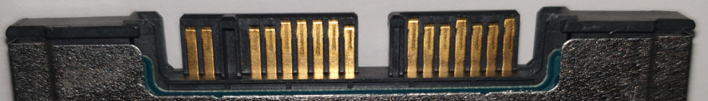

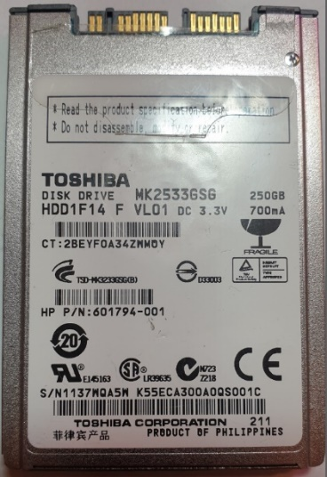

DYSK 1.8” Apacer SLC HALF (połowa długości) **Slim** SATA 15+7. Σ=> 22 pin

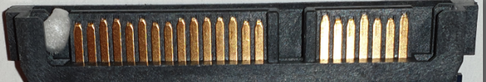

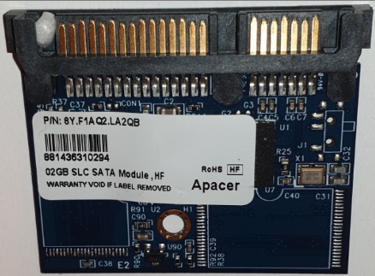

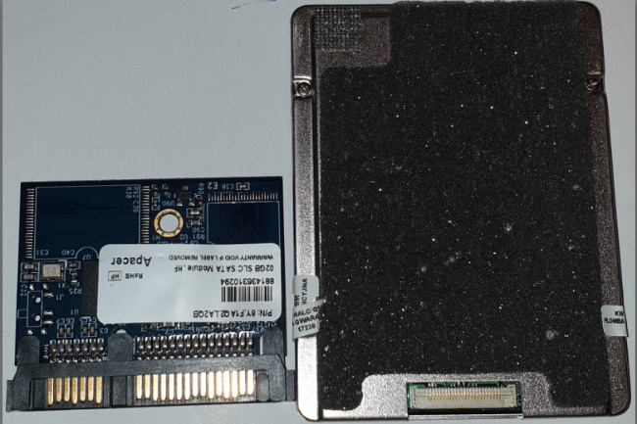

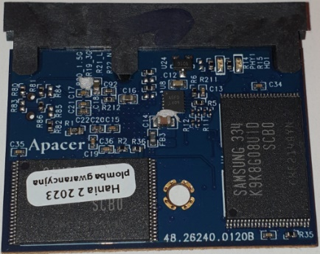

DYSK 1.8” Toshiba PATA ZIF. Σ=> 40 pin.

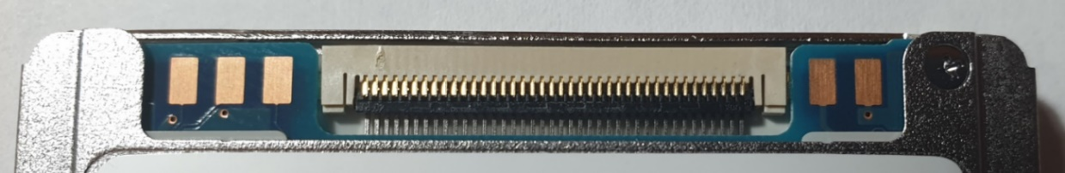Wysokość 8 mm.

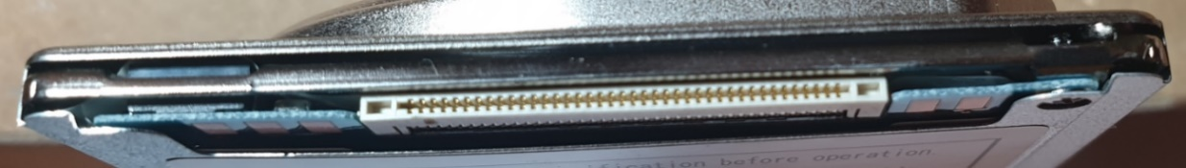

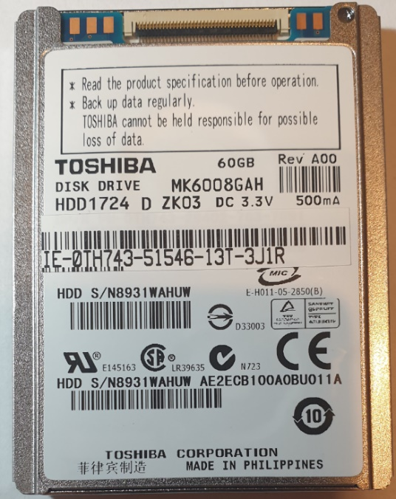

DYSK 1.8” Samsung SSD LIF SATA. 2x24 Σ=> 48 pin.

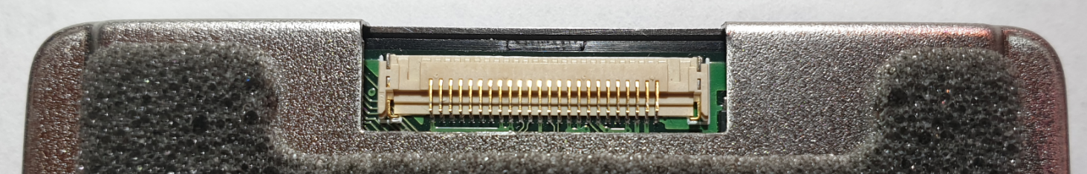

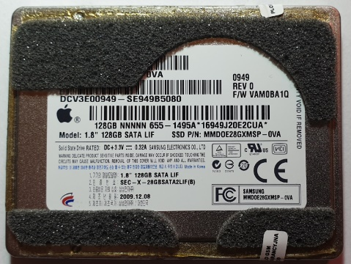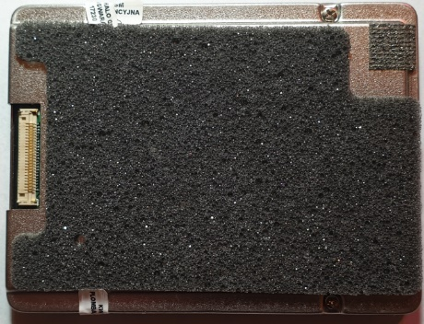

**ROZMIAR 1.7”**

DYSK 1.7” KityHawk HP\Citizen, IDE. Piny 2x25 Σ=> 50 pin.

Dysk twardy w formacie 1.3".

Faktyczne wymiary dysku są jednak inne. A wraz ze złączem, o wiele przekraczają 1.3" :

bez złącza 1.44" (36.5 mm) x 2.0" (50.8 mm) x 0.414" (10.5 mm)

wraz ze złączem 1.70" (43.5 mm) x 2.0" (50.8 mm) x 0.414" (10.5 mm)

1" = 25.4 mm

waży około 1 uncji (28 g)

Wprowadzony przez HP, wyprodukowany przez Citizen Corporation.

C3013A 20MB to HP Kittyhawk I.

C3014A 40MB to HP Kittyhawk II.

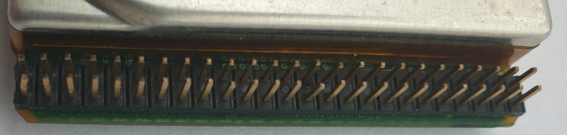

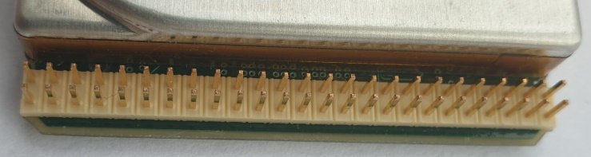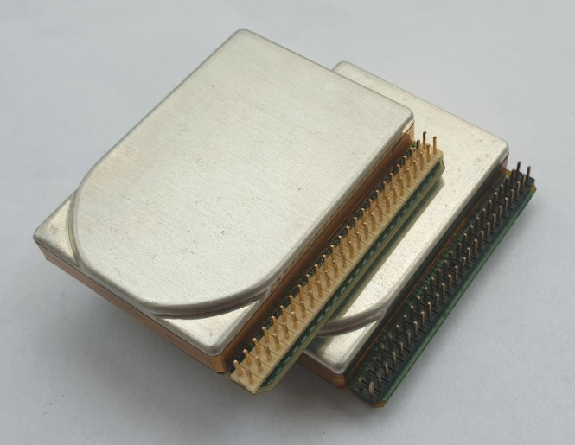

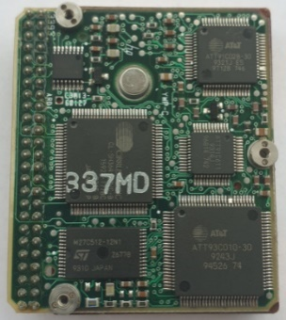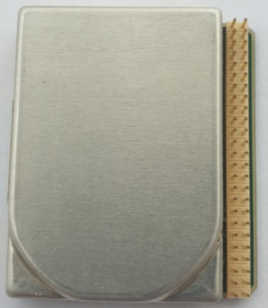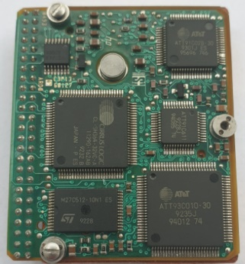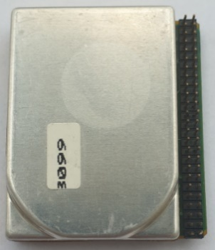

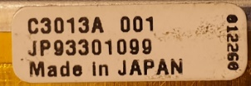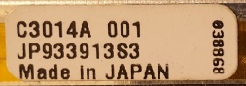

C3013A 20MB to HP Kittyhawk I C3014A 40MB to HP Kittyhawk II.

**ROZMIAR 1”**

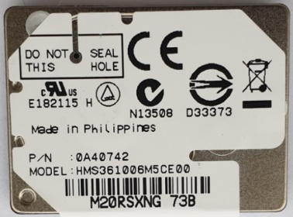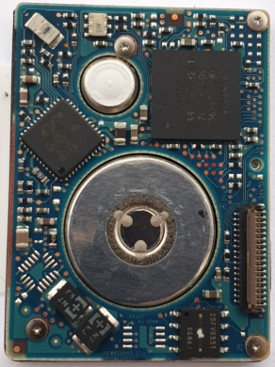DYSK 1” Hitachi

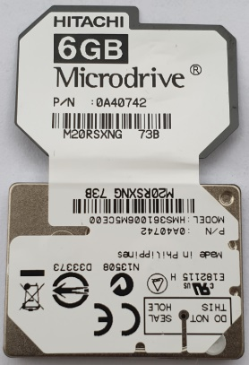

**ROZMIAR 0.85”**

DYSK 0.85” Toshiba from Nokia N91

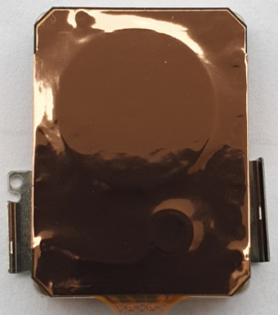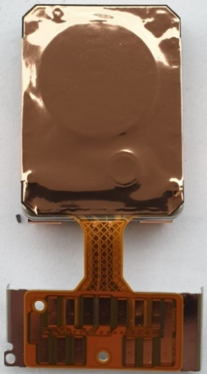

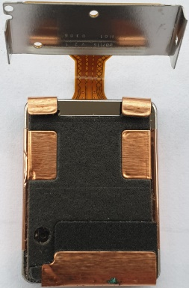

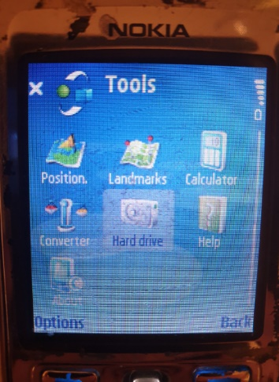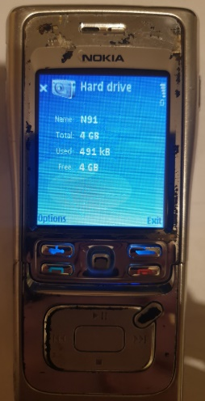

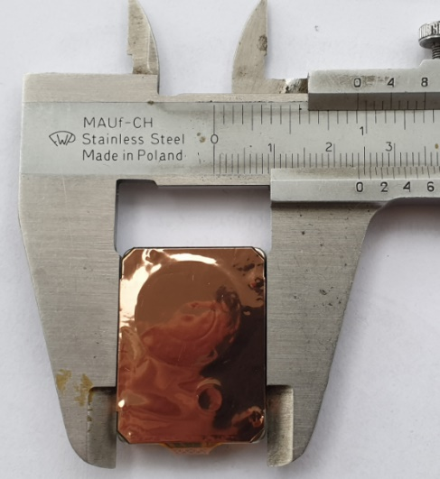

**Różnice między interfejsami ST412 i ST506:**

**Szybkość transferu danych:**

* **ST412:** 5 Mb/s
* **ST506:** 10 Mb/s

**Kodowanie danych:**

* **ST412:** MFM (Modified Frequency Modulation)
* **ST506:** MFM (Modified Frequency Modulation)

**Pojemność dysku:**

* **ST412:** Maksymalnie 20 MB
* **ST506:** Maksymalnie 40 MB

**Złącze:**

* **ST412:** 20-pinowe
* **ST506:** 34-pinowe

Złącza w interfejsach ST412 i ST506 służą zarówno do sterowania, jak i do transferu danych.

**Złącze 20-pinowe w interfejsie ST412:**

* **Pin 1-10:** Transfer danych
* **Pin 11-16:** Sterowanie
* **Pin 17-20:** Zasilanie

**Złącze 34-pinowe w interfejsie ST506:**

* **Pin 1-20:** Transfer danych
* **Pin 21-30:** Sterowanie
* **Pin 31-34:** Zasilanie

Dodatkowe piny w złączu ST506 umożliwiają przesyłanie większej ilości danych i zapewniają lepszą kontrolę nad dyskiem twardym.

Dyski IBM WDL-330P używają interfejsu ESDI (Enhanced Small Device Interface). Interfejs ESDI jest następcą interfejsu ST506 i oferuje kilka kluczowych zalet:

* **Wyższa przepustowość:** ESDI może przesyłać dane z prędkością do 10 Mb/s, podczas gdy ST506 jest ograniczony do 5 Mb/s.
* **Większa pojemność dysku:** ESDI obsługuje dyski twarde o pojemności do 1 GB, podczas gdy ST506 obsługuje dyski o pojemności do 40 MB.
* **Ulepszone zarządzanie błędami:** ESDI posiada wbudowane funkcje sprawdzania i korekcji błędów, co zapewnia większą niezawodność danych.

**Interfejs MFM nie jest obsługiwany przez dyski IBM WDL-330P.**

**Dodatkowe informacje:**

* Dyski IBM WDL-330P to dyski twarde o wysokości 5,25 cala i pojemności 330 MB.
* Dyski te były popularne w komputerach klasy PC w latach 80.